ScriptForge

ScriptForge is a helping tool to keep your constants like Layers, Tags, Sorting layers, and Scenes updated time and again. Never again will you need to re-update your constants whenever the order or names of any of them change.

They can be automatically generated for you, so you don't have to keep track of the manually. Constants can be generated for a range of things like Calling Line Identification (CLI), payments, e-mails, etc.

ECMAScript 2015 (ES6), often known as JavaScript, is supported by ConnexCS ScriptForge and is processed on the server in a secure sandbox (an isolated testing environment that lets users open files or run programs without impacting the platform, system, or application on which they are executing). It is intended to offer high throughput and low latency. It is designed for scripts and compact programs. Larger applications should be executed on external hardware through ScriptForge.

The existence of a fair-usage policy restricts the expected results if there is unnecessary resource utilization or if any damage is caused to the sandbox.

Now, let’s have a look at how to build and assign the scripts.

Configuration

1. Build Script
2. Sign into your account
3. Click on the ‘Developer’ tab (on the extreme left) and then the ‘Script Forge IDE’ option. Your screen will look as shown in figure 1.

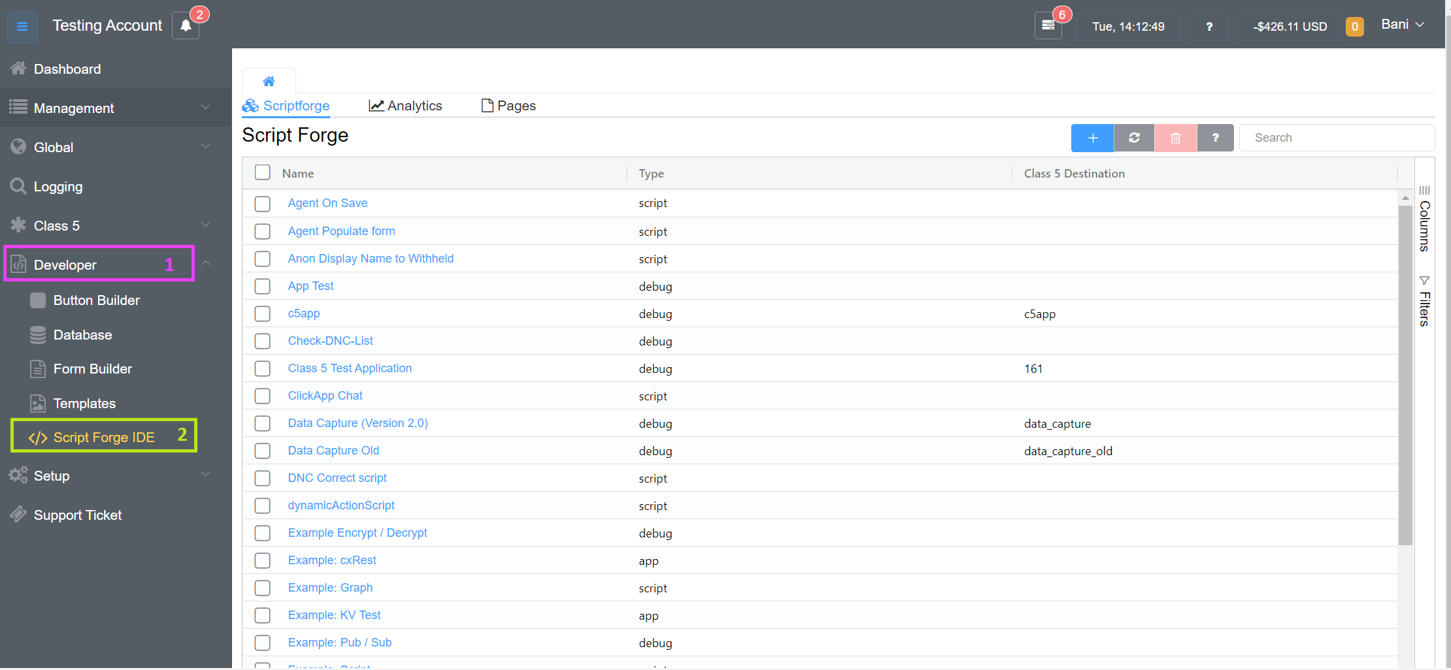

Figure 1: Selecting ‘Developer’ and ‘Script Forge IDE’

1. To add a new script, click on  the top right
2. Thereafter, a dialogue box will appear as shown in figure 2

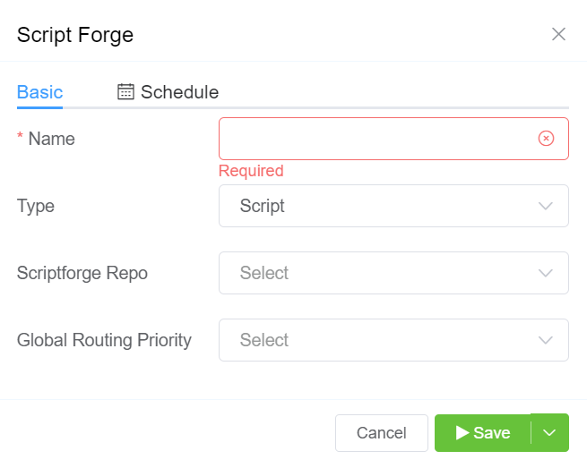

Figure 2: Script Forge dialogue box

1. In this dialogue box, there are two tabs i.e., ‘Basic’ and ‘Schedule’. Let’s talk about the ‘Basic’ tab first.
2. First fill out the ‘Name’ of the script (ref. figure 2).
3. Select the ‘Type’ of the script, from the two options, ‘Script’ or ‘App’ as shown in figure 3.

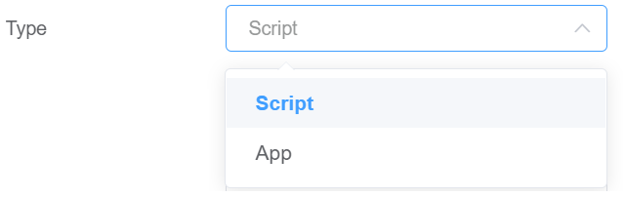

Figure 3: Script Type

* **Script:**  This is a "synchronous" execution and is the quickest way to run custom code. This should be used primarily for computations or manipulation. It is unable to operate with promises or use libraries.
* **App:** Applications with plenty of features often come with a preset (whitelist) of available modules, although this comes at the cost of a little increased latency.
* **Driver:** A driver works as an intermediary between ConnexCS and any external system. You can write drivers to bridge the ConnexCS DID provisioning system to a provider of your choice or build more complicated alerts.

1. After the Script selection, select the type of ‘Scriptforge Repo’ as shown in figure 4. Scriptforge repos are the predefined repositories that are under GitHub/GitLab. It is more convenient as all the scripts are accessible under the Scriptforge repo. For example, there are two scripts Collo/Add Outbound Header and many more can be added from the repository.

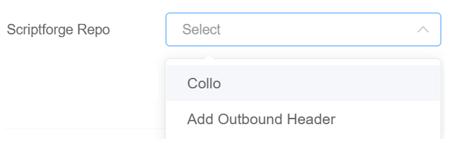

Figure 4: Scriptforge Repo Type

1. Lastly, select the type of ‘Global Routing Priority’ status, as shown in figure 5. When global routing priority is set, the system is going to use this specific script forge on all customer accounts. The script will not be limited to a single customer but every customer. You have 3 options to set the routing priority, either you can ‘Run First’, ‘Run Last’, or ‘Disable the script’.

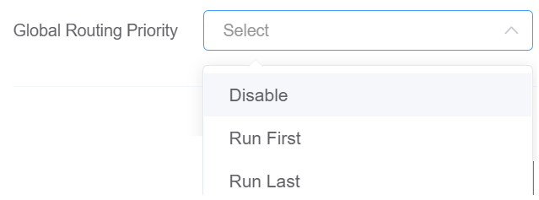

Figure 5: Scriptforge Repo Type

1. After filling out these parameters, you need to write the script or use the available scripts. If you have to write the script, fill out the details as shown in figure 2. The script will be added to the list of scripts. For example, if the script name is “ClickApp Chat”, it will be visible on the ‘Script Forge’ screen as shown in figure 6.

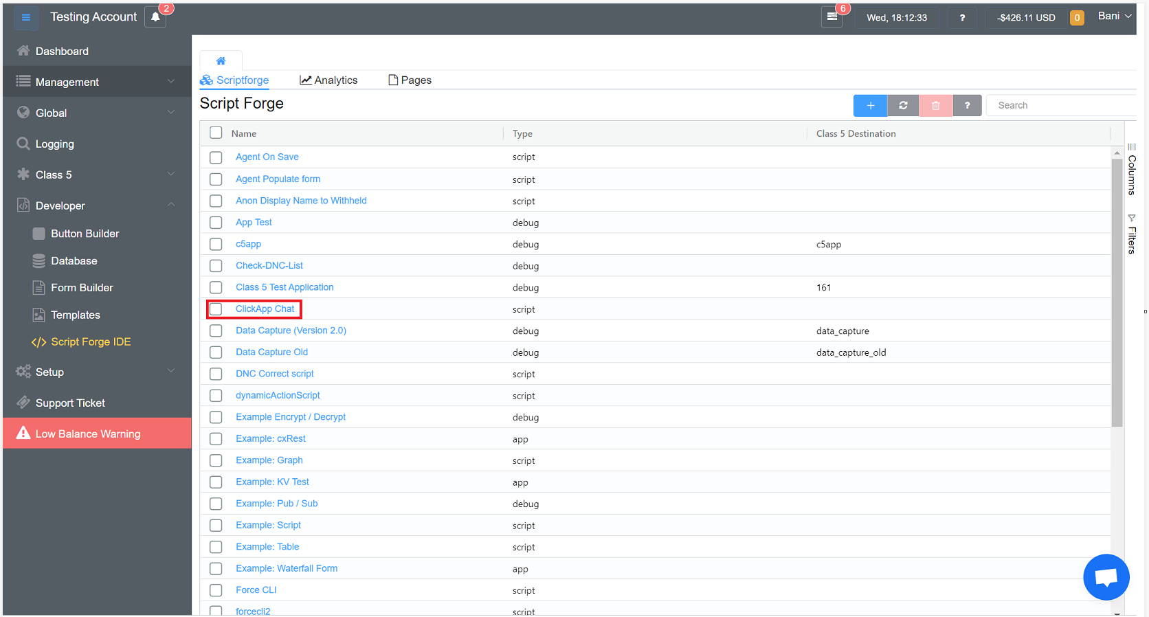

Figure 6: List of Scripts

1. Click on the created script, and in the blank section, write the code and save it, run and save other tools are also available as depicted in figure 7.

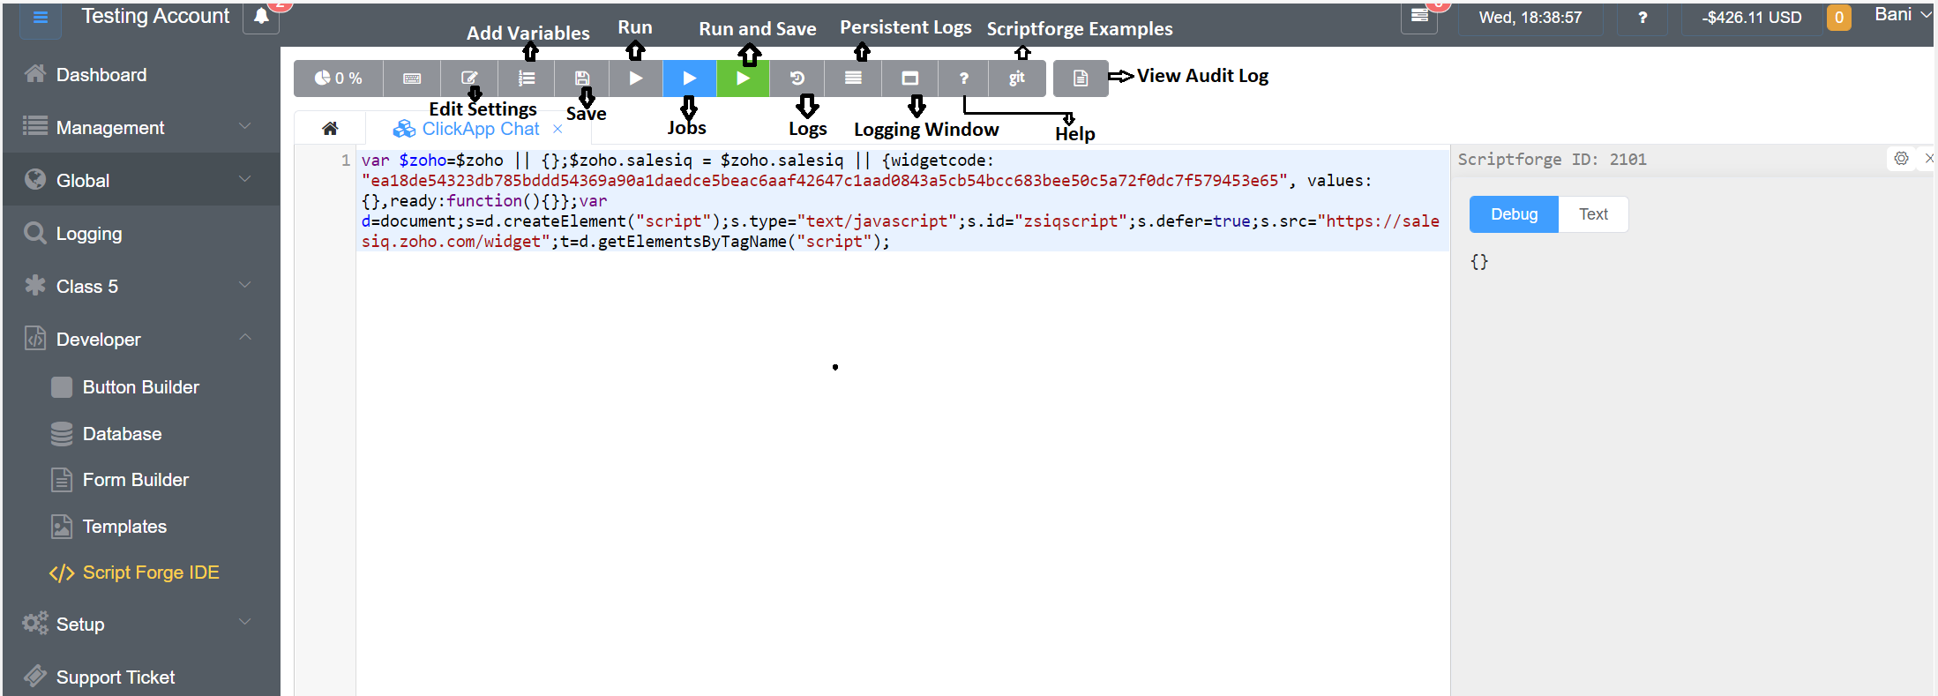

Figure 7: Script Page and various options

1. Another interesting feature in Scriptforge is the scheduling of the scripts. One can schedule the scripts for the customers by choosing the various options available as shown in figure 8. Just check on the ‘Set Value’ and select the parameters at your convenience.

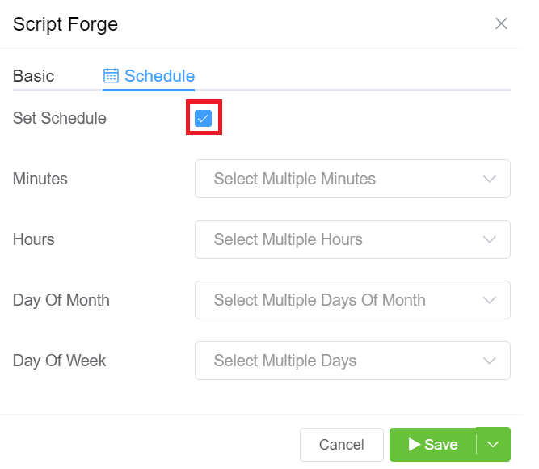

Figure 8: Scriptforge Scheduling

1. Click on  and check the results on the screen.

Once the scripts have been created, these can be assigned to the customers. Let’s have a look at the process of assigning.

1. Assign Script
2. From the control panel select the ‘Management’ dropdown and click on ‘Customer’ as depicted in figure 9.

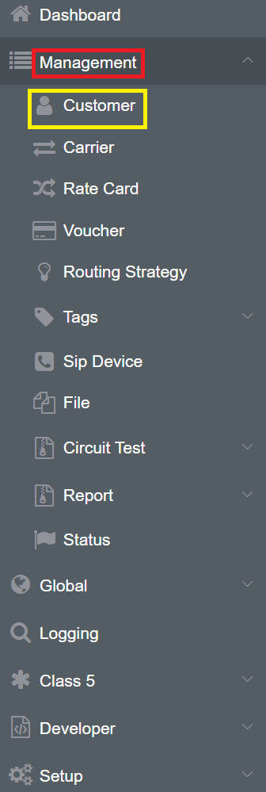

Figure 9: Assigning the Script

1. You will be able to see the customer screen depicted in figure 10.

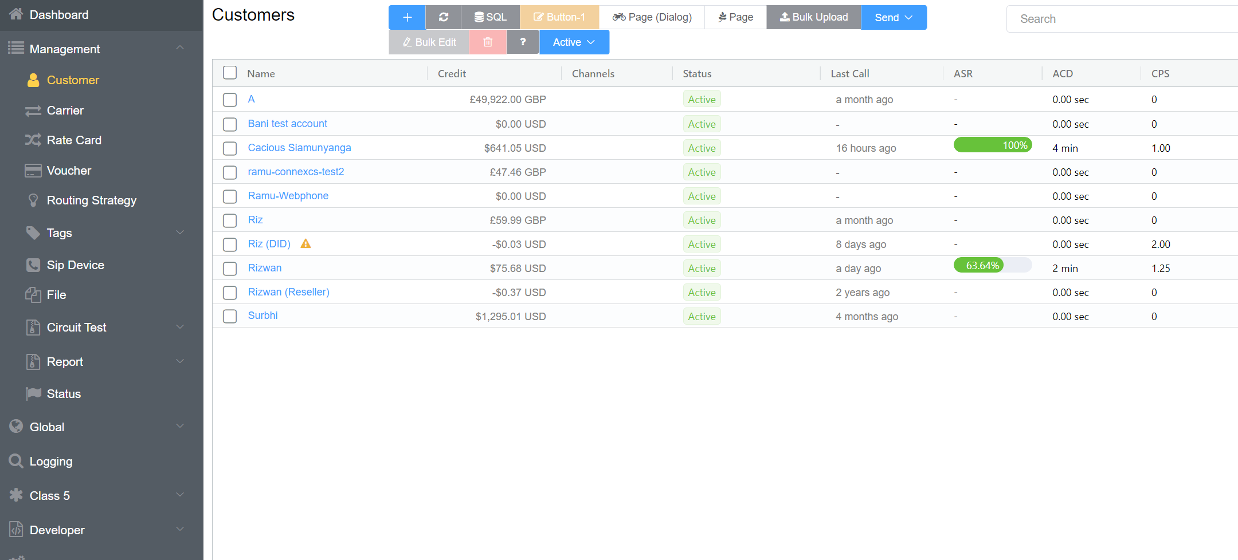

Figure 10: Customer Screen

1. Click on any of the customers and the following screen will appear as in figure 11, then click on ‘Routing’.

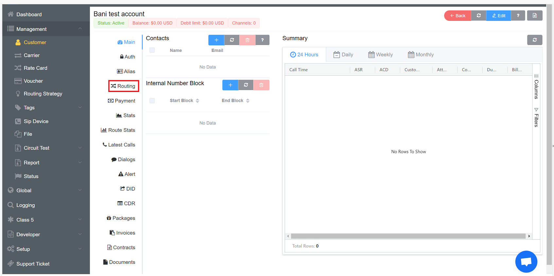

Figure 11: Main Screen view

1. The routing page will appear as depicted in figure 12. Click on the customer’s name, for example, Surbhi Customer (in this case).

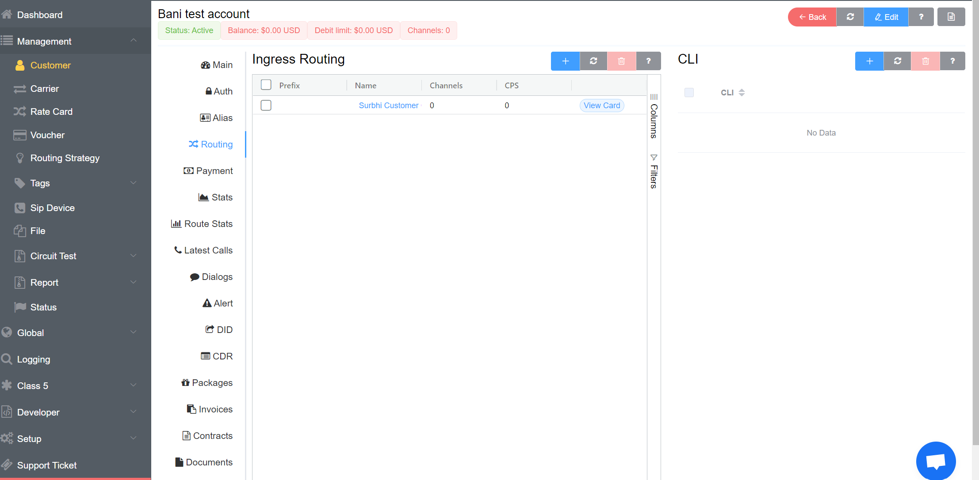

Figure 12: Routing page

1. After you select the customer, click on Script Forge and select the appropriate script (ClickApp Chat) and click on ‘Save’ as shown in figure 13. After saving the script successfully, the script will be updated to the customer’s account. You can also select the ‘Rate Card’ from the ‘Basic’ tab.



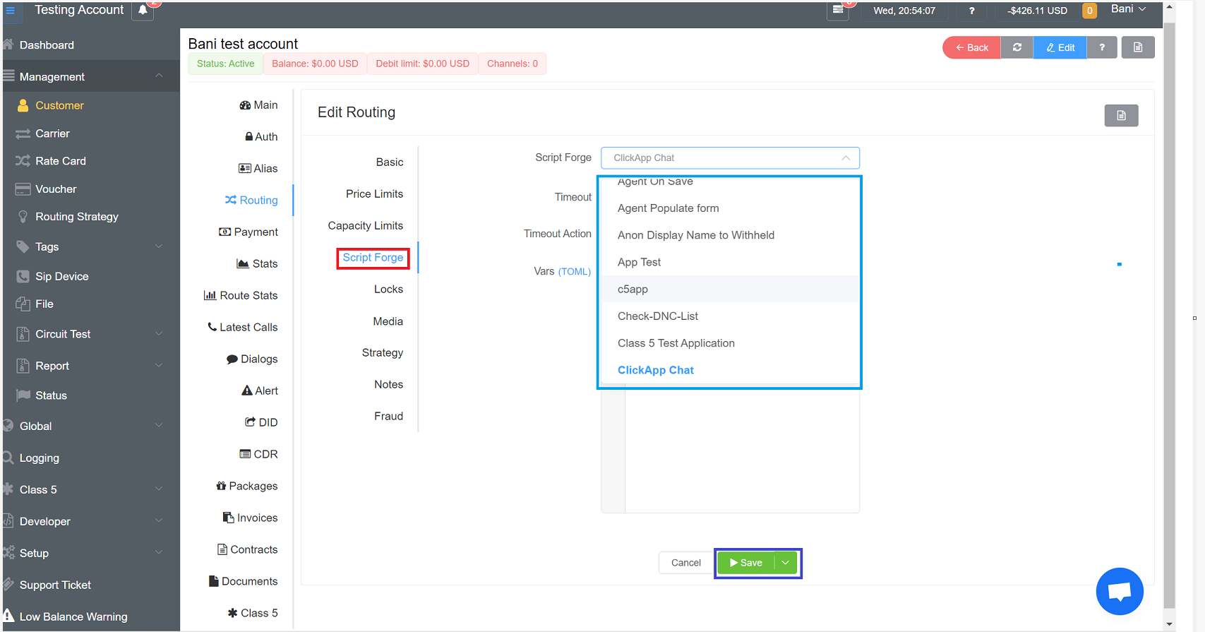

Figure 13: Script Forge screen

1. Set the **Timeout** to specify how long it will run before timing out. The **Timeout Action** is entered manually and must be formatted as [sip response code] [sip response message] as seen in figure 14.

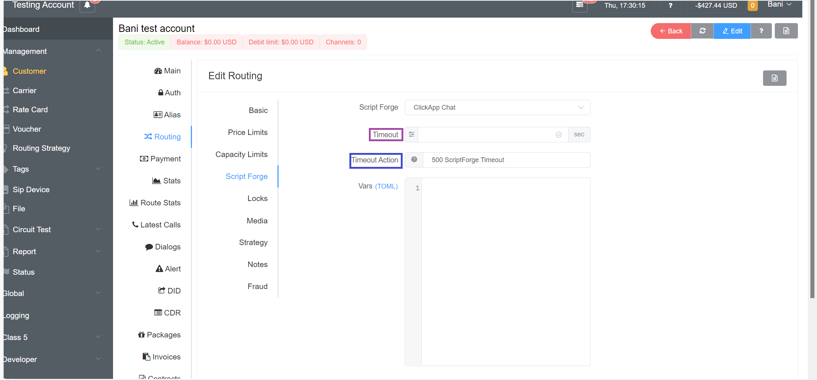

Figure 14: Timeout and Timeout Action

1. Here, you have 3 saving options as shown in figure 15.

* **Save and Continue**: Exit the Customer screen
* **Save and Stay:** Save the customer, but stay on the screen (helpful when adding multiple Customers at a time)
* **Delay and Save:** Select a time to elapse before saving the Customer, delaying the setup or change.

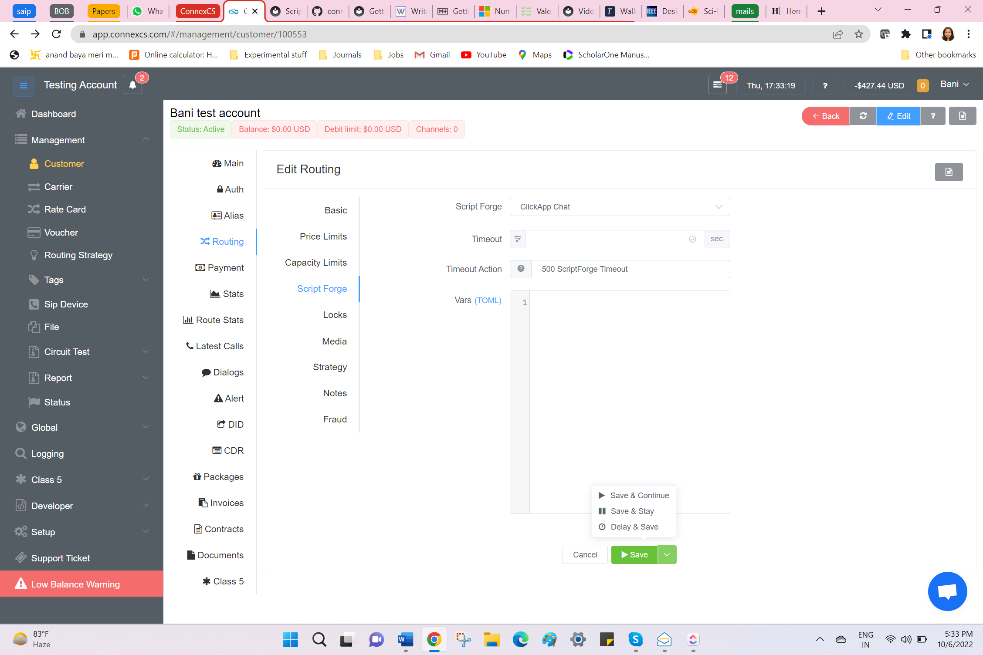

Figure 15: Saving Options

1. To check the script of a particular customer, you can visit the ‘Latest Calls’ tab and you will have the information on the different scripts the customer has been equipped with.

Here, the script has been created and assigned the scripts to the customers. Another feature in the Script forge is the ‘**Analytics’**. Analytics will help you build graphs for the channels, PDD, ASR, etc. You can check the graph by changing the filter such as finding the graphical representation for 1 day or month or 6 months. An effective tool for obtaining, processing, and displaying graphs and tables. Numerous pre-existing reports are available for viewing and editing, and you can also design your graphs using data from both internal system data sources and external third-party systems. Additionally, data can be processed by Script Forge utilizing tools like the preProcess function and MapReduce.

To assist you to choose your essential metrics, you can construct customized reports. Here are a few instances of the things our clients have created:

* **Ticket Count:** Integration with a third-party ticketing system that shows the number of open tickets for a certain customer.
* **FOREX:** Display information on the dashboard
* **603/604 Block Report:** Showcase the top blocked CLIs by customer and carrier.
* **CLI Stats:** Exhibit stat per CLI
* **ISO Code Stats:** Display stats by Country ISO

1. Go to ‘Developer’, then ‘Scriptforge’, and click on ‘Analytics’ and there will be a list of scripts (figure 16) on which different types of analytics can be performed.

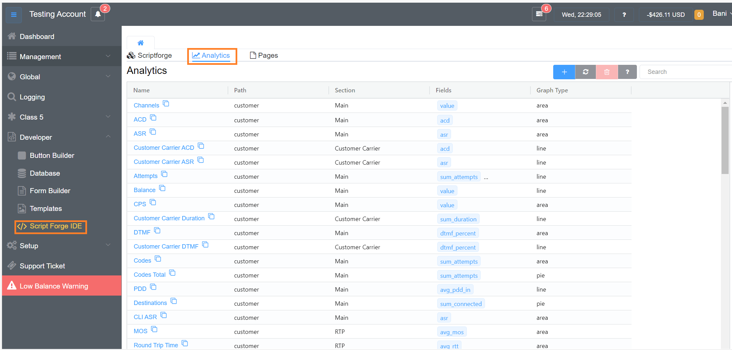

Figure 16: Analytics Screen

1. Click on any of the Script/Driver/App, and you will see a screen as depicted in figure 17.

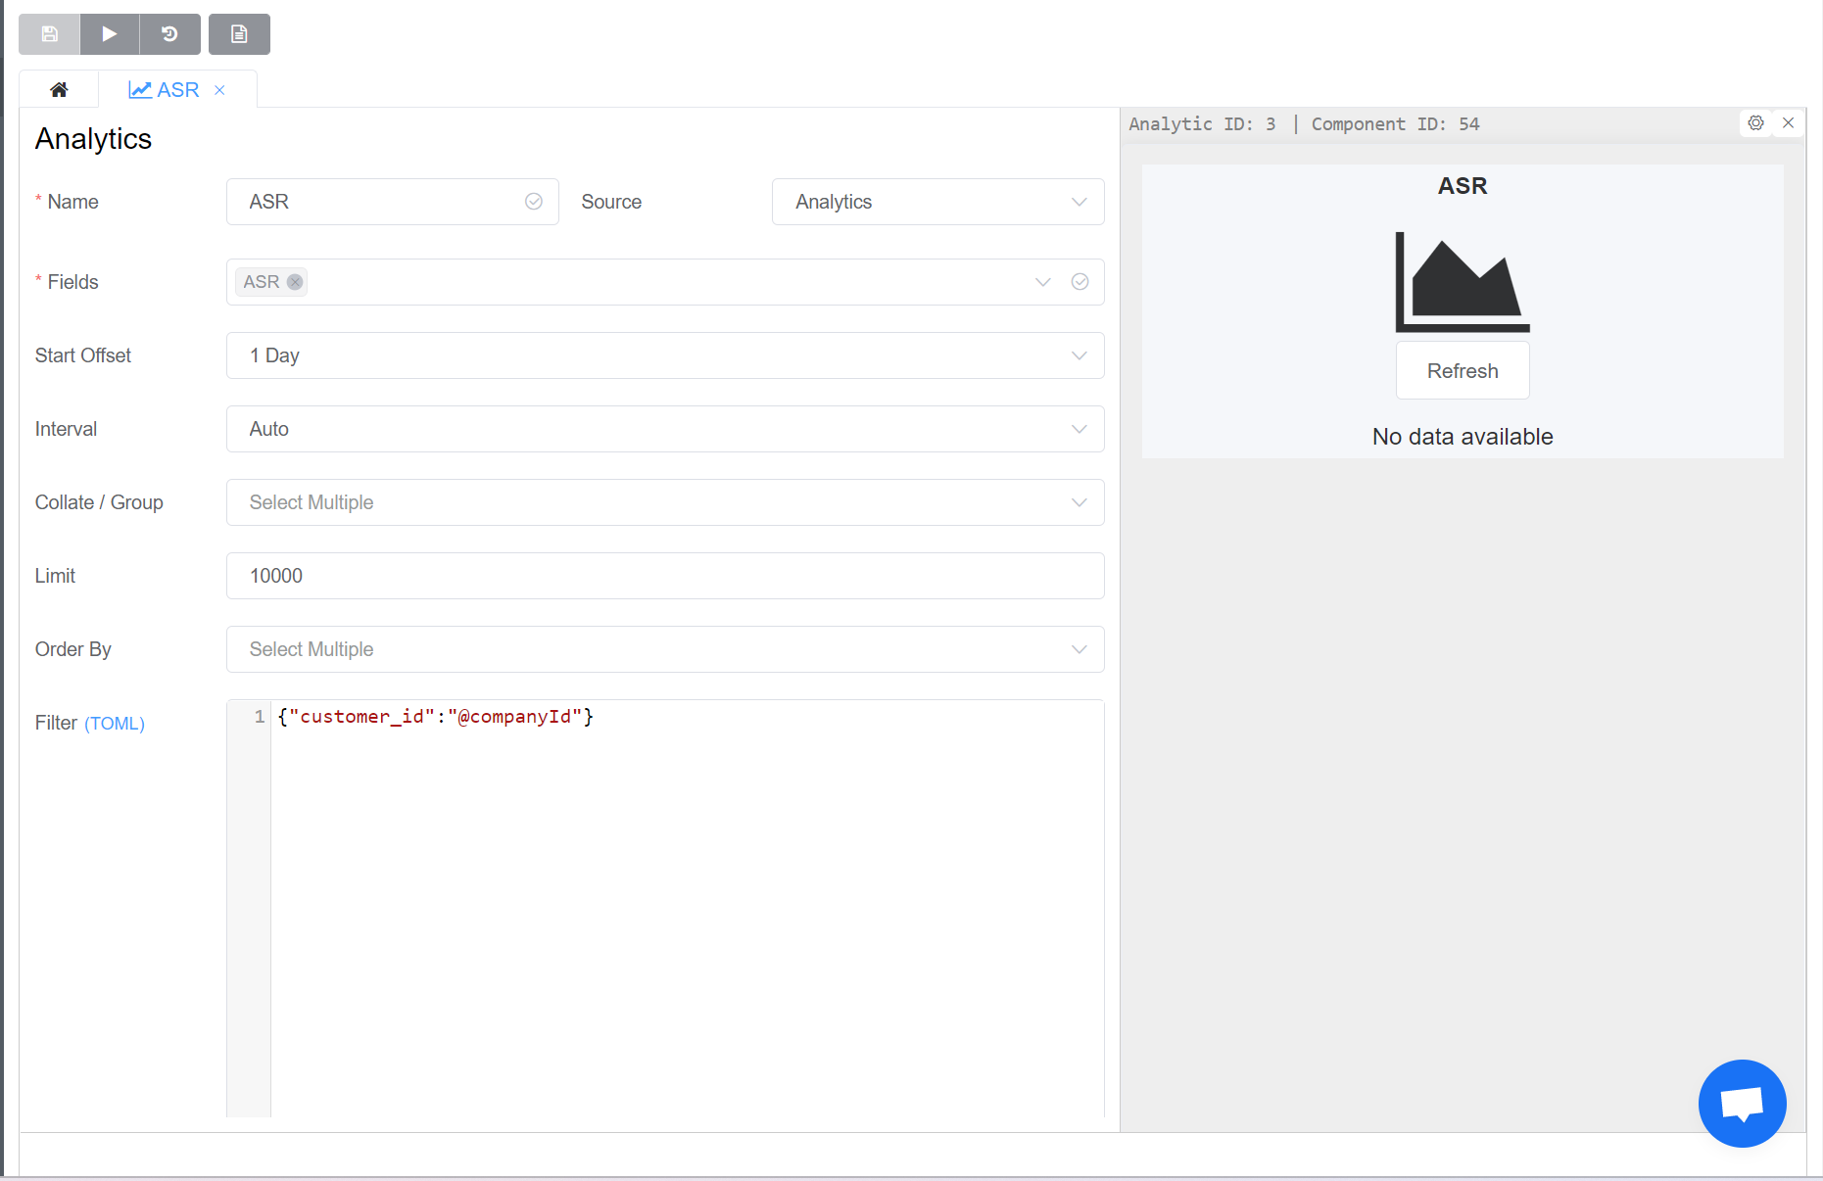

Figure 17: Analytics Screen of a particular customer

1. When you select the ‘Source’ dropdown there are many options (figure 18). Source means from which database file the information can be extracted. Let us go through the options one by one.

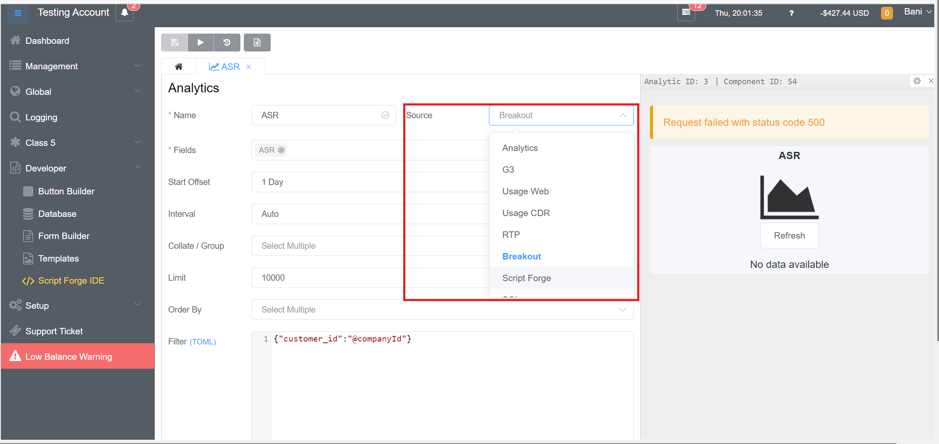

Figure 18: Selecting the Source

* **Analytics**: It provides Big Data multi-vector queuing. multi-vector querying refers to a query search based on a list of vectors and the indexation of entities with more than one representation. It should not be used for accurate financial data.
* **G3:** It provides Single value time-series data.
* **Usage Web**: Using the web database
* **Usage Call Detail Record (CDR)**: Checking the CDR database
* **Usage Real-time Transport Protocol (RTP):** Checking the RTP database
* **Breakout:** Breakout report produces the usage of the customer and their ACD, ASR, and Profit generated. We set the date and time for the period we want to see the report. It provides accurate financial data but with limited query vectors.
* **Script Forge:** It is a Custom Script Forge data source, that can be used to combine other data sources or even import external data in real-time.
* **SQL:** Generates structured reports that include tables containing data, graphs, pictures, and charts. These reports are kept on a server that users can access at any time and run using the parameters they specify.

1. After selecting the Source, you have an option to select the fields you want to include on your graphs or tables. “Fields” are the parameters to be displayed in the Graphs or the Tables. The field parameters change according to the source you select as shown in figure 19.

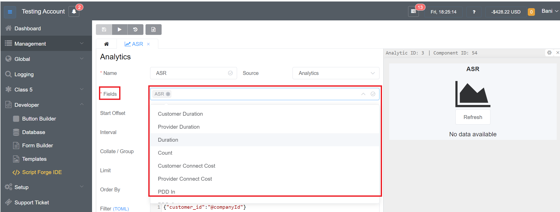

Figure 19: Selecting the Fields

1. When a data selector is absent from the page, the start offset indicates how far back in time the query will go. So, you can see the data for minutes to hours to months to 1 year (figure 20).

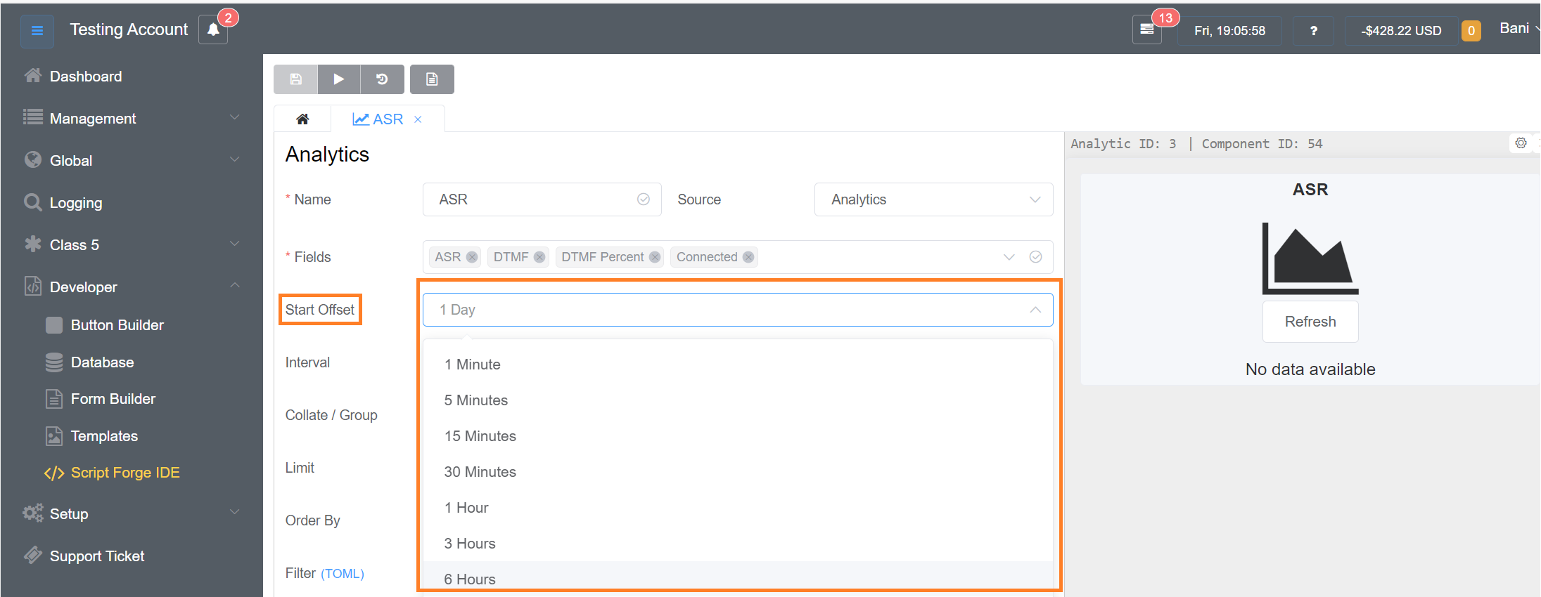

Figure 20: Start Offset

1. To group the data on the graph, choose the ‘Interval’. Let’s briefly discuss the ‘Interval’ options as shown in figure 21.

* **Auto:** Automatically picks a suitable temporal resolution.
* **Collate:** Condense all the temporal data (for instance, when choosing ACD, it will only show a single scalar number rather than a date/time axis).
* **Time-based:** Choose this option to organize the data by time, like for seconds, minutes, hours, days, or even months.

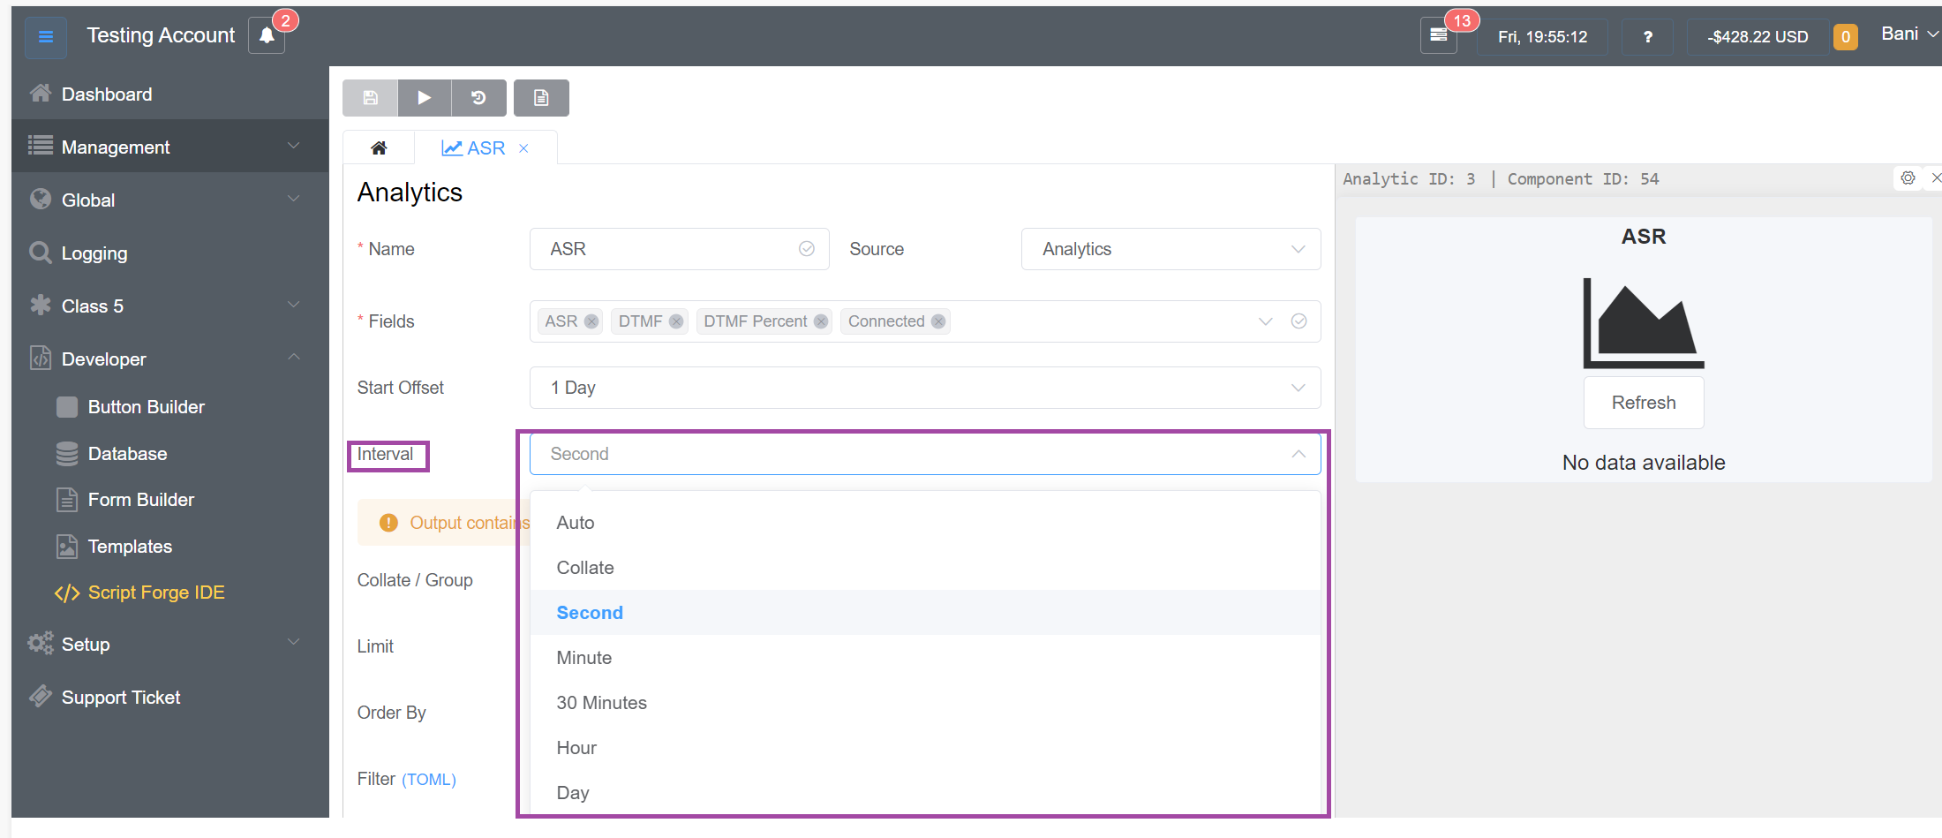

Figure 21: Interval Selection

1. **Collate/Group**: Decide whether to combine the data into one group (figure 22). (For instance, if you choose "Customer," you would receive a different value for each customer)

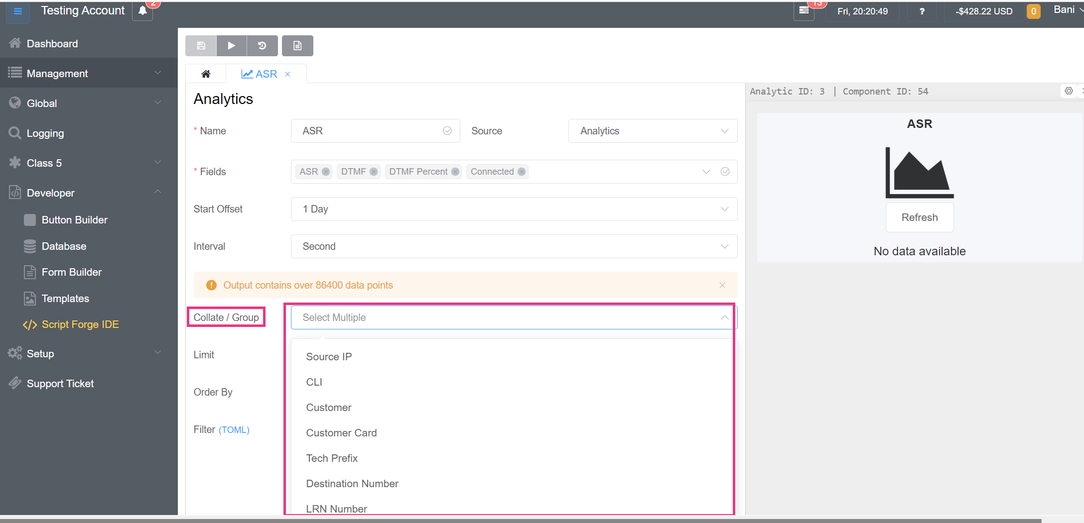

Figure 22: Collate/Group

1. Click on  to set a cap on how much of the compiled data should be displayed. Avoid adding excessive values.
2. The column that you want to use to organize the data. This works well when it is combined with limits. For instance, show the top 10 customers with Automatic Call Distribution.

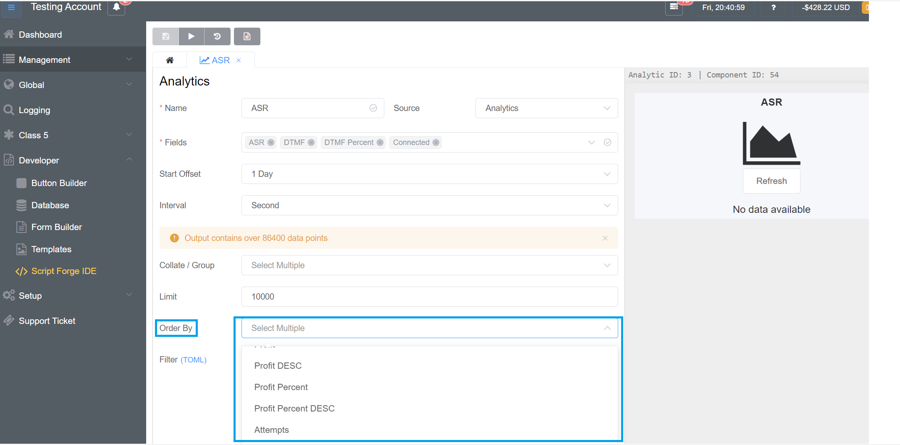

Figure 23: Order By Options

1. Utilize a filter to automatically filter the data displayed based on variables accessible from the server rendering the page (figure 24). A filter’s format varies based on the data source.

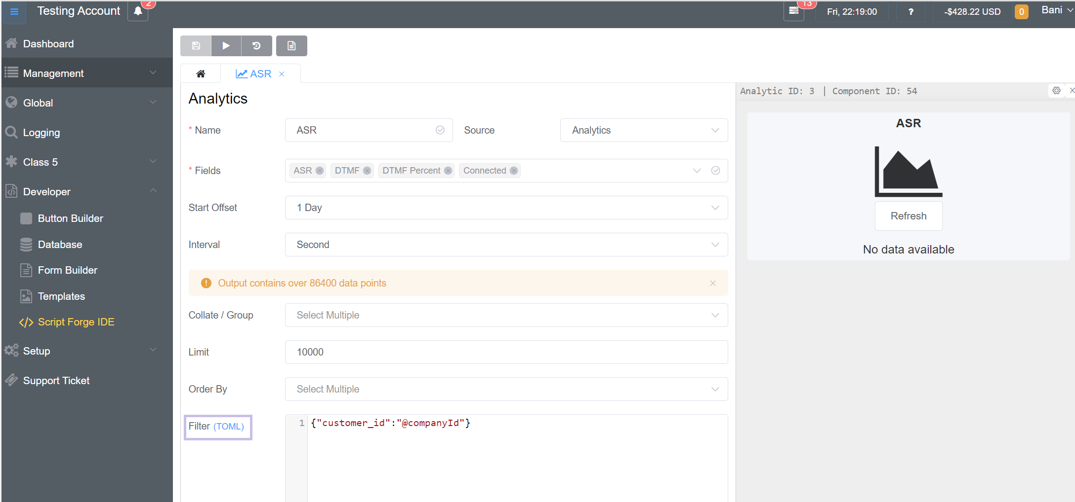

Figure 23: Filter

1. After filling out all these details, you will see them on the top left.
2. To run the parameters, click .
3. To view the logs (graphs, tables, etc) click on ‘View Logs’ .
4. To view the audit log, click on  and a screen will appear as shown in figure 24.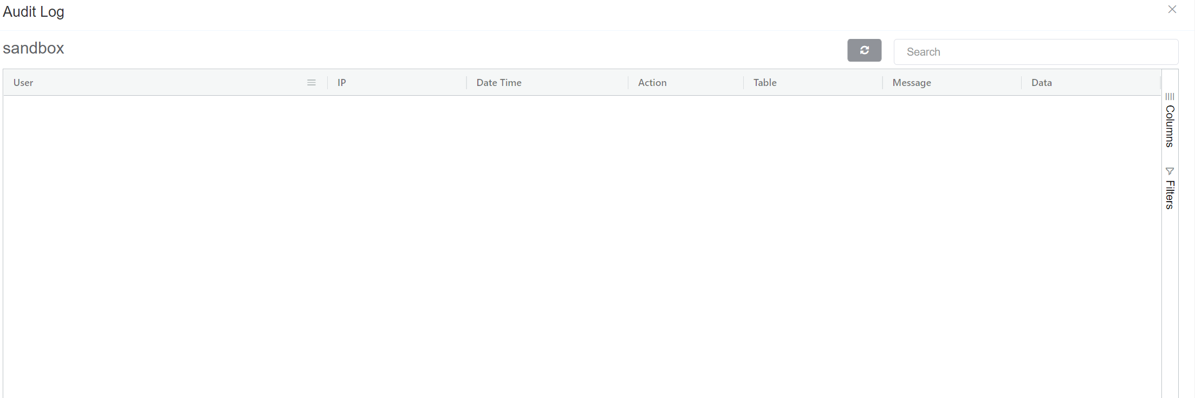

Figure 24: View Audit Log

1. Now to Create New Analytics click on **Config** as depicted in figure 25.

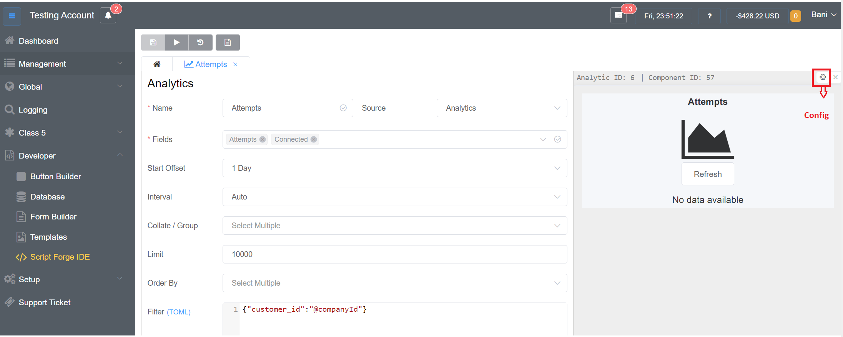

Figure 25: Create New Analytics

1. You will be redirected to the screen as seen in figure 26.

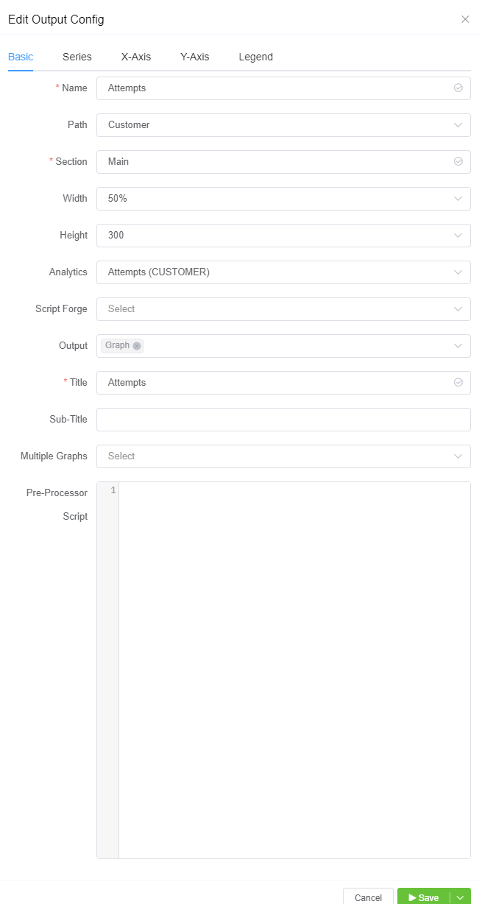

Figure 26: Create a New Analytics screen

1. Let’s discuss the **Basic** tab of creating a new **Analytics**

* **Name**: Mention the name of the channel
* **Path**: Select the location to display the data using the dropdown
  + - * + **Customer**: Management > Customer > Stats
        + **Carrier**: Management > Carrier> Stats
        + **Analytics**: Developer> Script Forge > Analytics
        + **Dashboard**: Dashboard> Displayed at the bottom
        + **Route**: Management> Customer> Route Stats
        + **Report**: My Reports> Debug/HTML/Graph/Table/Vue/Render

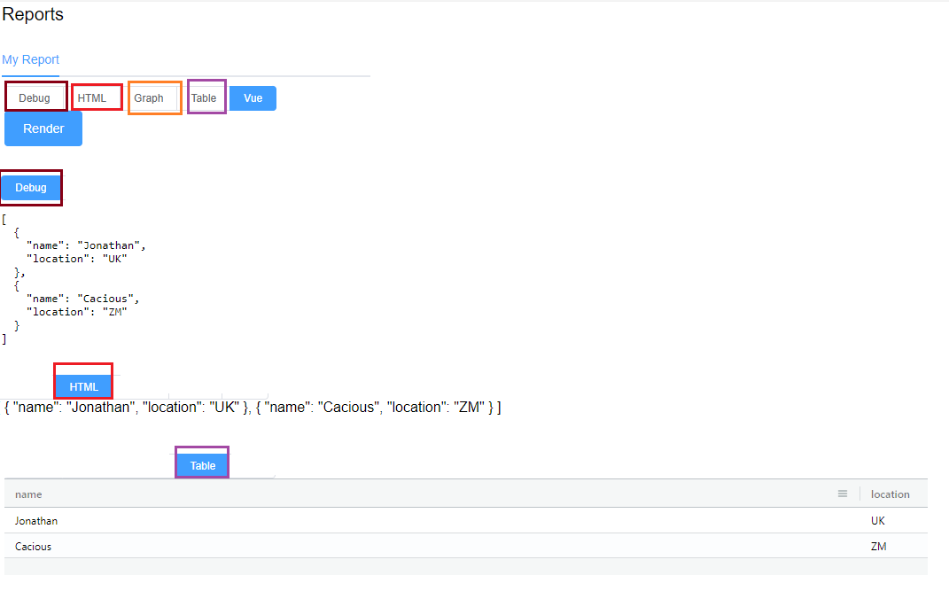

**Report: SQL> Debug/Table/Vue/ Render**

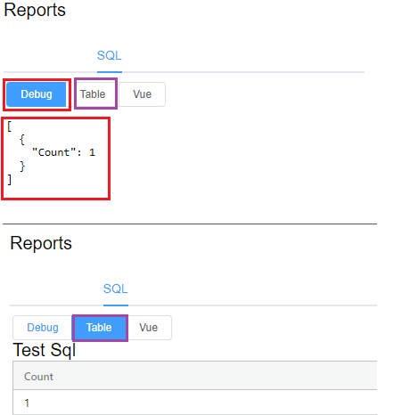

**Report: Breakout Report> Debug/Table**

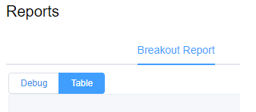

**Report: DTMF Report> Debug/Table**

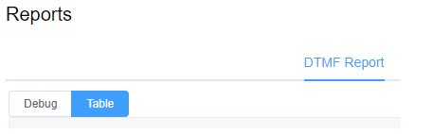

* + - * + **Logging: Logging> SIP Tracing**

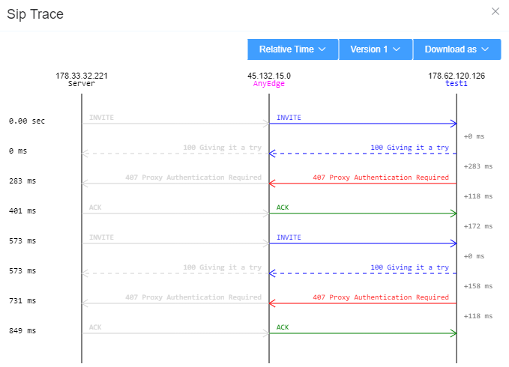

* + - * + **AnyEdge: Setup> AnyEdge**

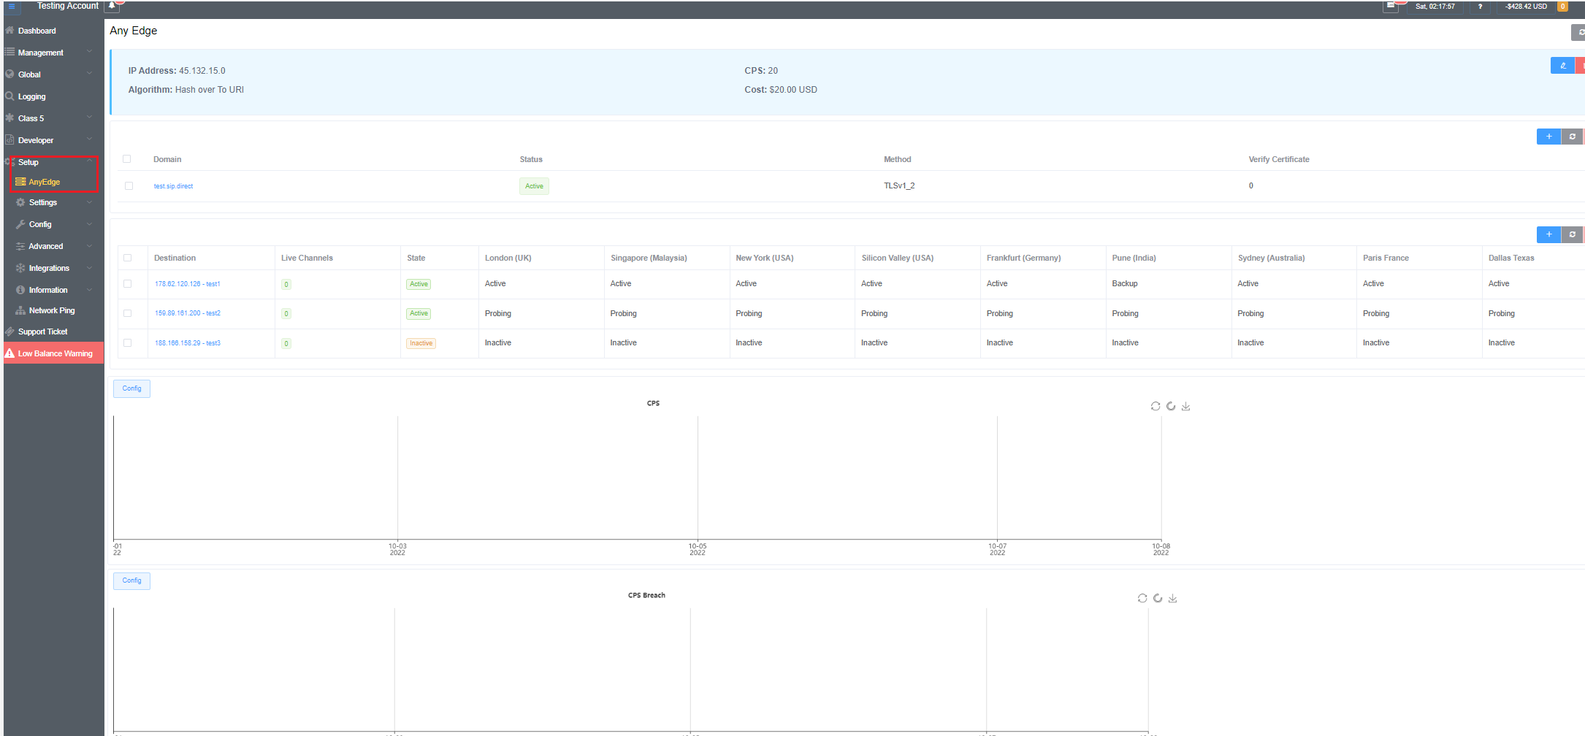

* + - * + **SIP User Authentication: Global> SIP User Authentication**

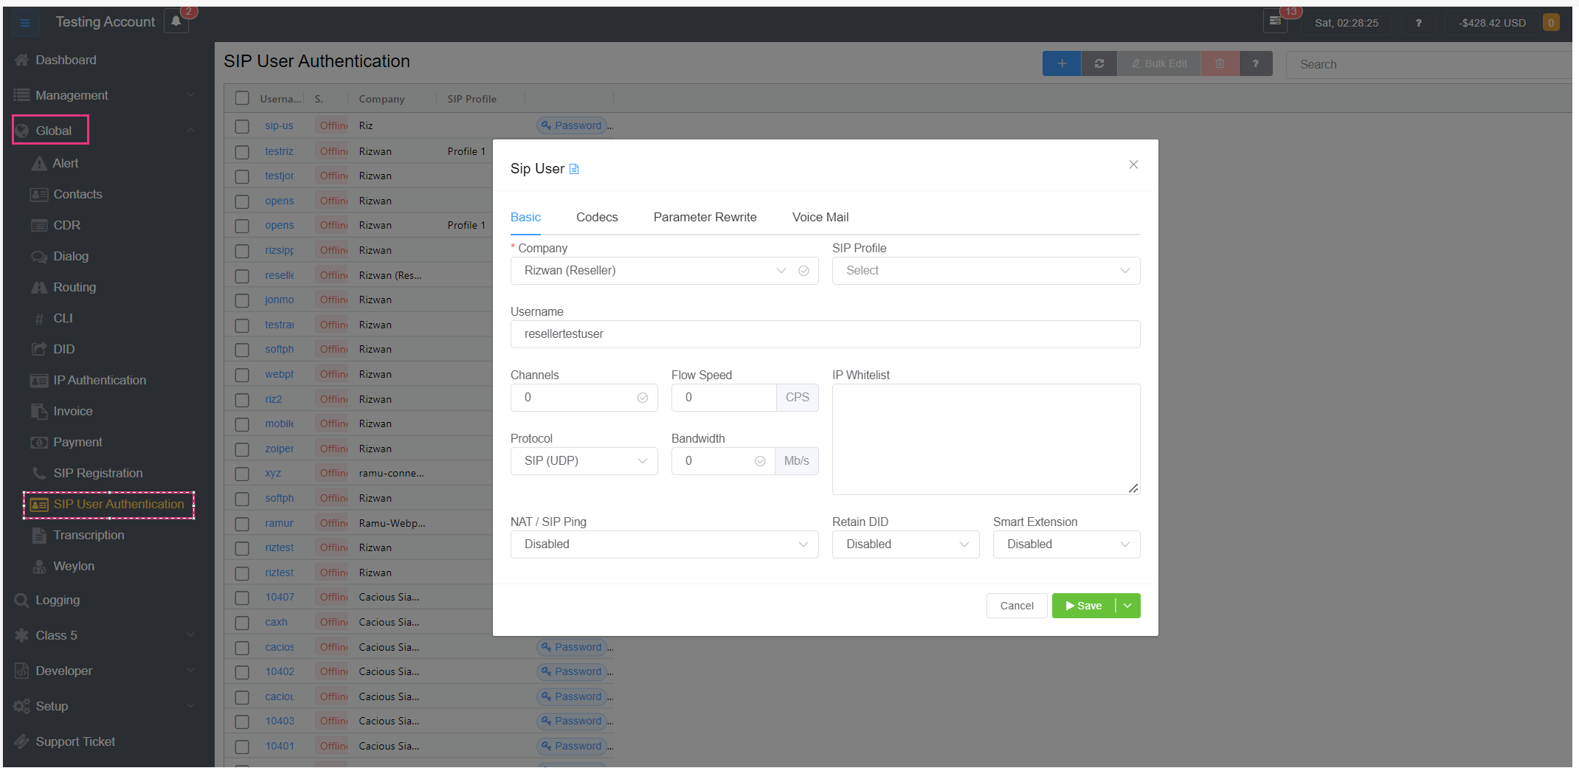

* + - * + **Portal Dashboard: Dashboard**

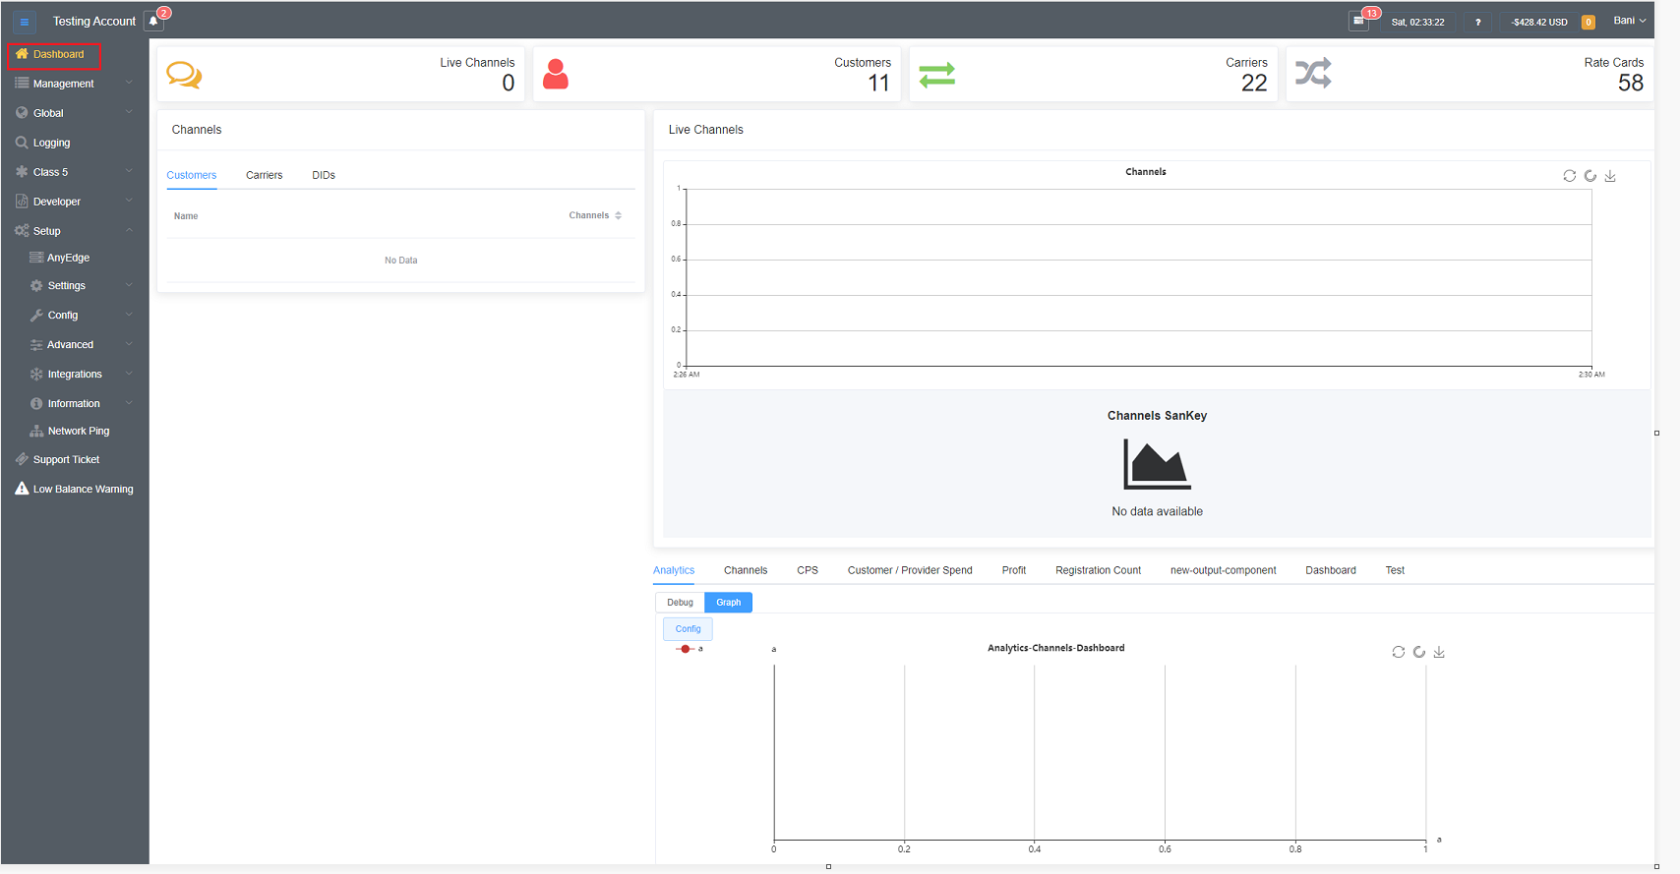

* **Section**: You can group analytic components when sharing the same name. This is often collated together in the same tab.
* **Width**: When the graph is rendered on a page with multiple graphs, select the portion of the page for the graph to occupy.
* **Height:** Choose the height of your graph from various options.
* **Analytics:** Choose the parameter for which you want to generate the analytics from the dropdown, like User latency, Daily Speed, Jitter, Packet Loss, Profit, etc.
* **Script Forge:** You can choose from the various scripts already in the repository or manually generated from the dropdown.
* **Output**: Select to render data in many ways, you can choose the various options from Graph, Table, Download, HTML, Vue, and Debug. You can choose one or multiple options.
* **Title & Subtitle:** Displays title and subtitle information on the rendered graph/table.
* **Multiple Graphs**: This option lets you position multiple graphs in horizontal or vertical directions or both. You have a wide range of choosing options from the dropdown menu.
* **Pre-processor Script:** This allows it to intercept and modify any SQL text sent to the database (or executed within a procedure script) before passing it on to the actual parser.
* Here, you have 3 saving options as shown in figure 26.
* **Save and Continue:** Exit the Customer screen
* **Save and Stay:** Save the customer, but stay on the screen (helpful when adding multiple Customers at a time)
* **Delay and Save:** Select a time to elapse before saving the Customer, delaying the setup or change.



Figure 27: Saving Options

**Pages**

Developers can use **Pages** to create customized input forms on the ConnexCS control panels.

1. Click  to create a new form.
2. Put the Name and Title of the page as depicted in figure 28 and click on Save.

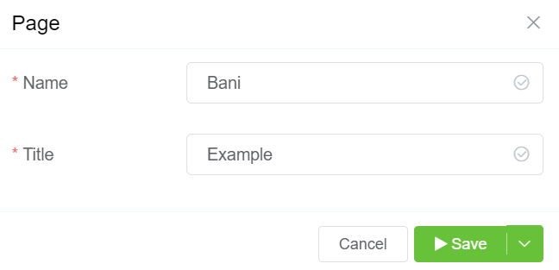

Figure 28: New Page Screen

1. You will see the screen with the various pages as depicted in figure 29, click on the Page Name which you created (**Bani** in this case).

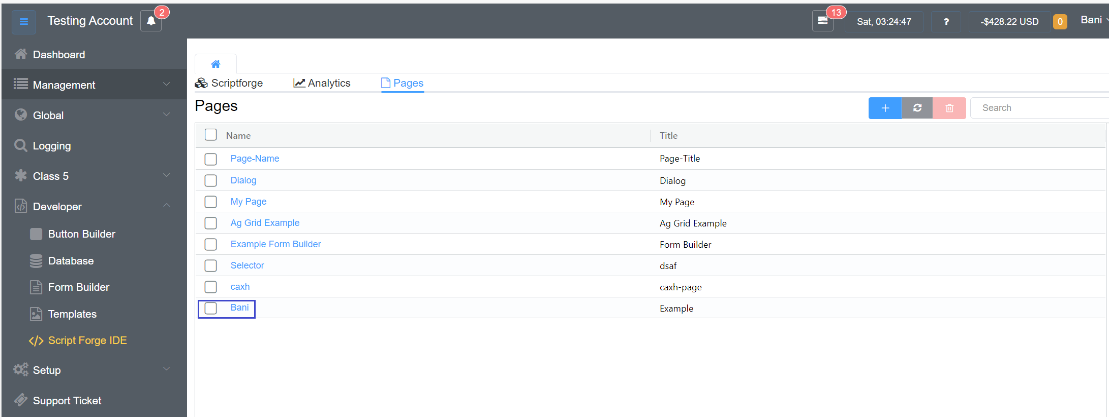

Figure 29: Pages Screen

1. A screen with various options displayed as **Basic Fields** as seen in figure 30**.** These tabs allow you to create a **form/page.**

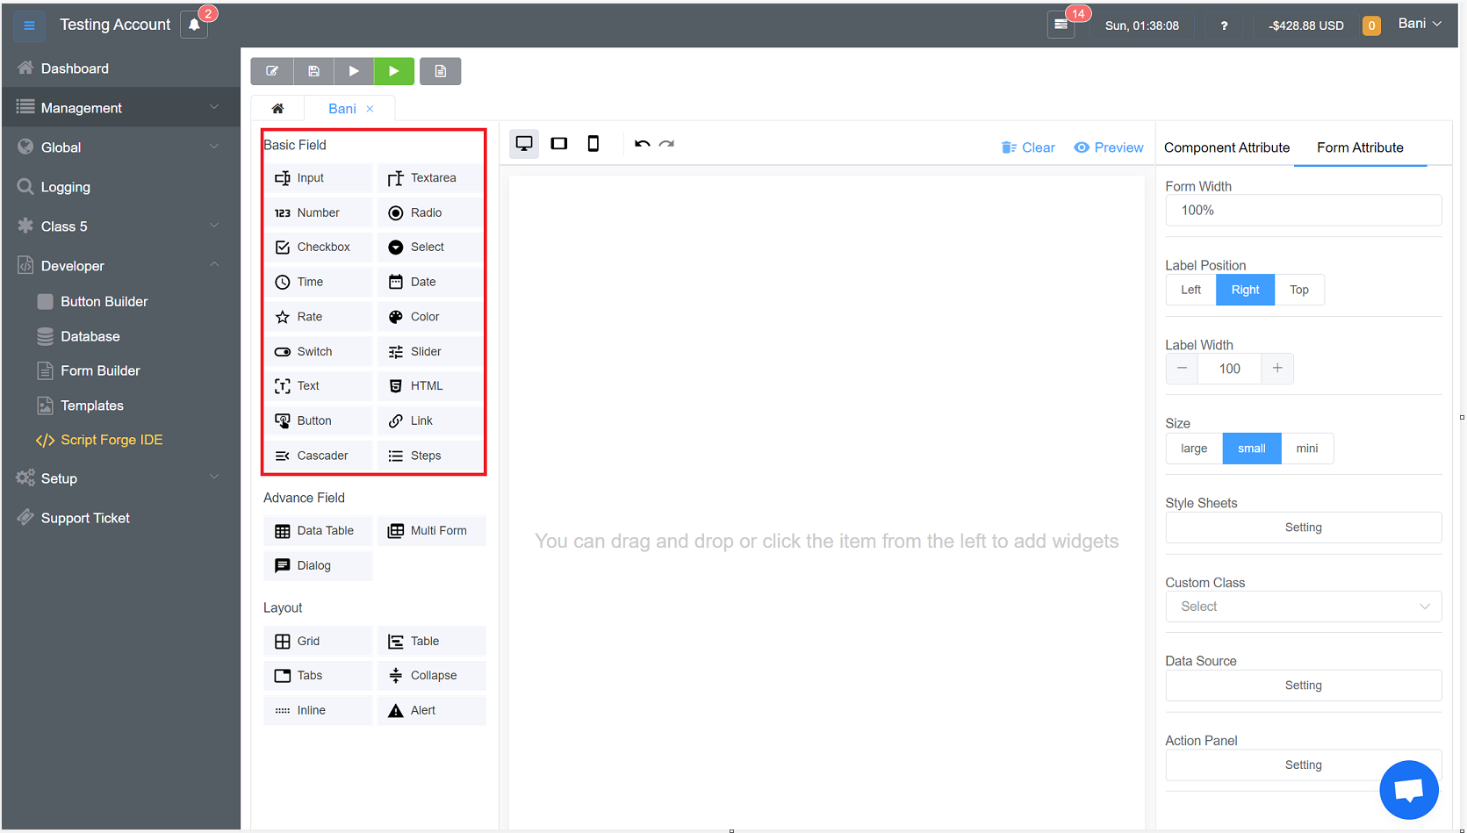

Figure 30: Basic Fields

Let’s discuss the functions of these fields one by one.

* 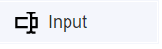**:** An Input Field is a way to make the text of a Text Control editable. Like the other interaction controls, it's not a visible UI element and must be combined with one or more visual UI elements to be visible.

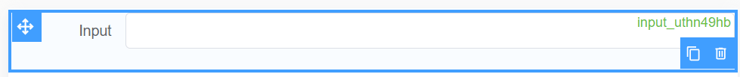

* 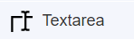 : The <textarea> element represents a multi-line plain-text editing control, useful when you want to allow users to enter a sizeable amount of free-form text, for example, a comment on a review or feedback form.

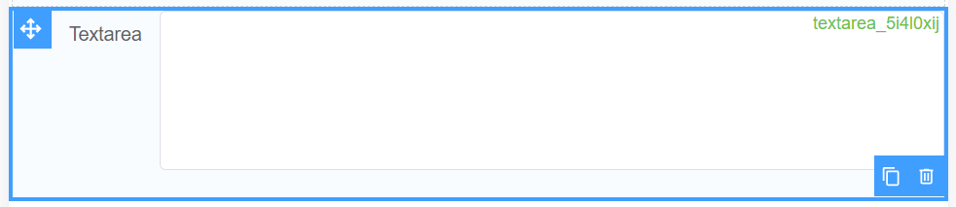

* 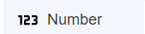**:** Defines a field for entering a number.



* : Where multiple controls exist, radio buttons allow one to be selected out of them all, whereas checkboxes allow multiple values to be selected.

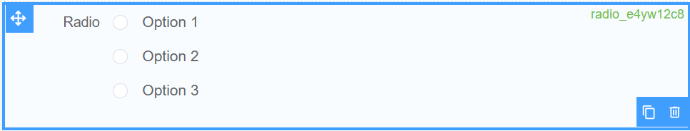

* 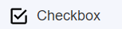: Checkboxes are used when there are lists of options and the user may select any number of choices, including zero, one, or several. In other words, each checkbox is independent of all other checkboxes in the list, so checking one box doesn't uncheck the others.

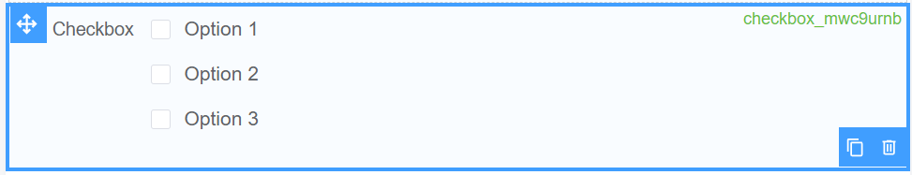

* 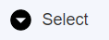:  A select button allows a user to select a value from a series of options.



* 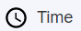: It allows the customer to publish the time.



* 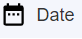: Allows the customer to publish the date.



* 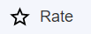: A rating is an evaluation or assessment of something, in terms of quality, quantity, or some combination of both. Therefore, you can add this where you want to rate the quality of a call, or cost or latency.



* : Allows you to change the color.

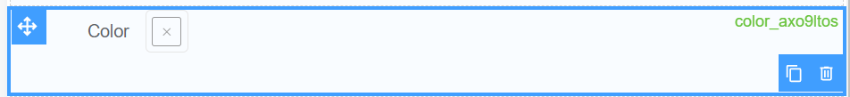

* : Allows switching between ‘true’ and ‘false’ values.



* : A control for selecting a single value from a continuous range of values.

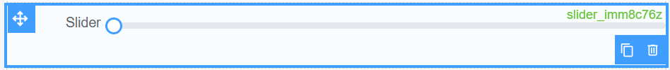

* 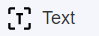: The UI text element displays a non-interactive piece of text to the user. Text elements can be used to provide captions or labels for other GUI controls or to display instructions or other text.



* 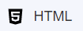: It gives you the option to write the HTML code.

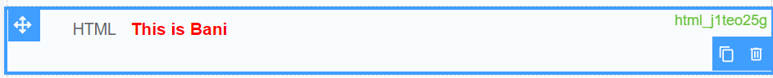

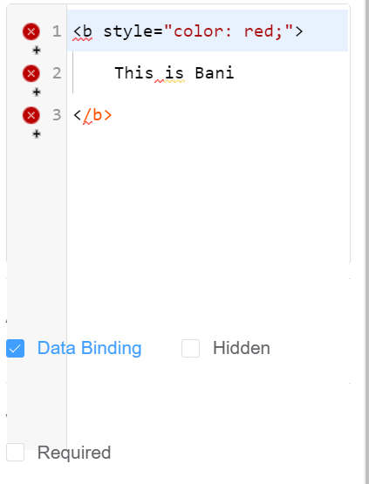

* : The button is responsible for performing an action.

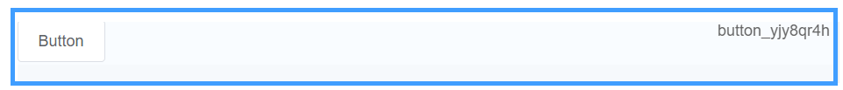

* 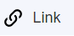: Link lets you add an external link to the page. When you click here you will be redirected to that website, document, etc.

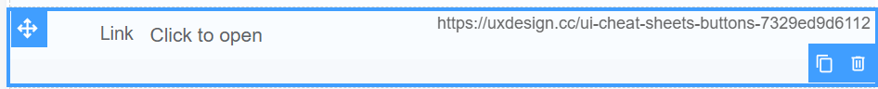

* : Cascader can be considered as a multi-level dropdown option.



* 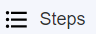: Steps can be used to show the progress of a process. For each completed step the step number will get black in color.

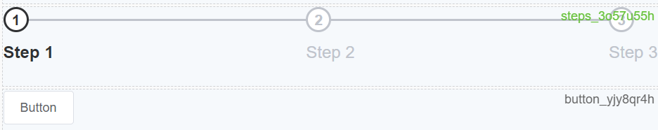

All the **Basic Fields** have been discussed, let’s throw some light on the **Advance Fields.**

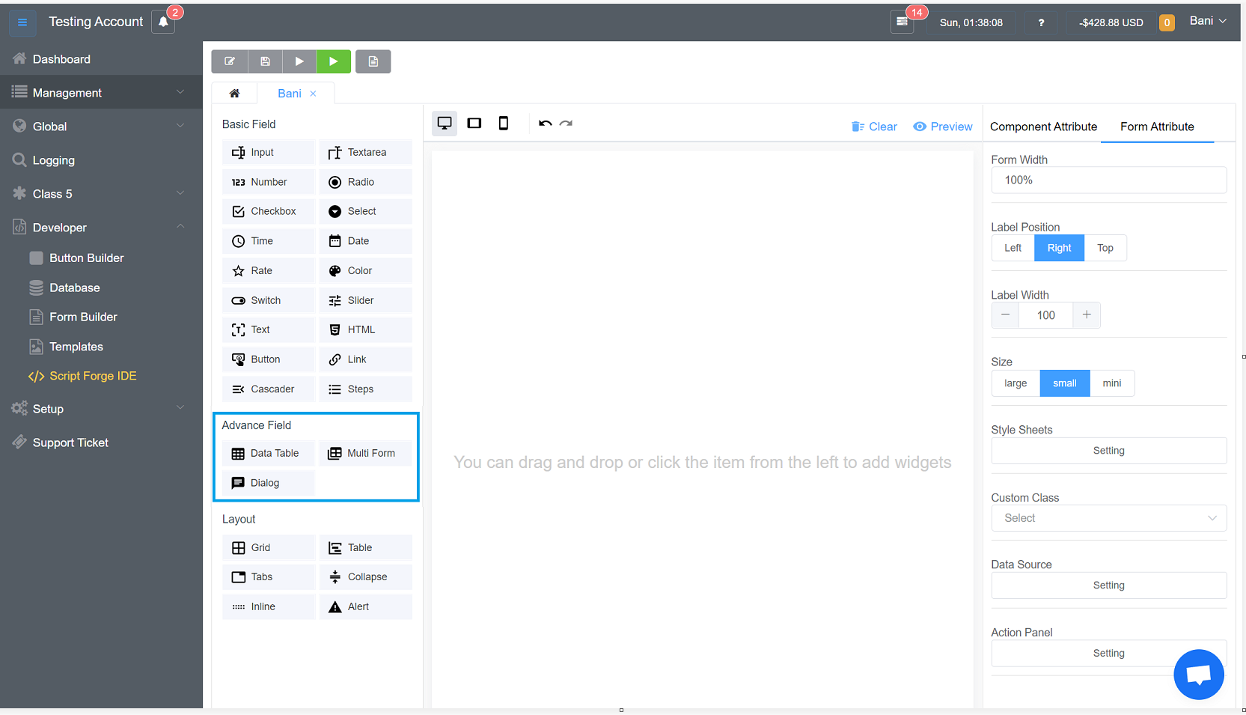

Figure 31: Advance Field

Let’s discuss the Advance Fields one by one

* 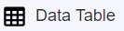: Data Table allows you to add many components of **Basic Fields** into this data table.

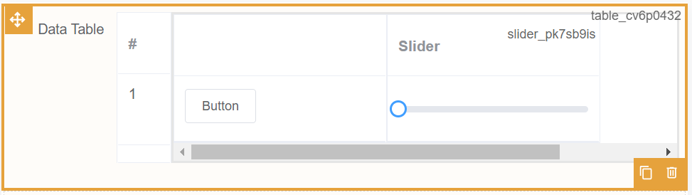

* 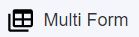: This feature allows you to prepare multiple forms. If you want multiple duplicate copies of the created form, you can use this advanced component.

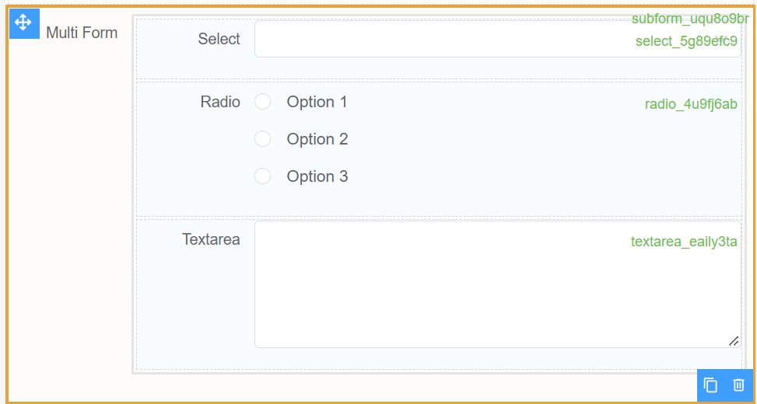

* 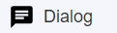: A dialog is a small window that prompts the user to make a decision or enter additional information. A dialog does not fill the screen and is normally used for modal events that require users to take an action before they can proceed.

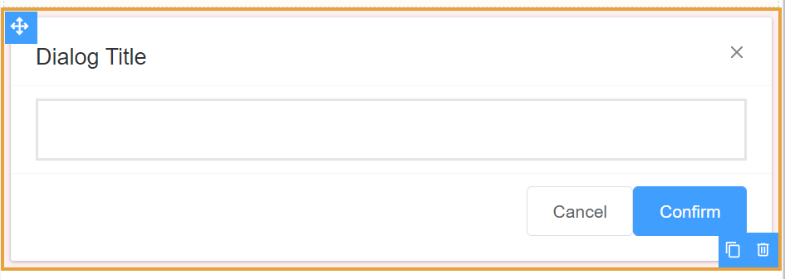

Let’s have a look at how we can arrange the different components. For the arrangement of elements, there is a **Layout** block. A discussion on various layout options is presented below.

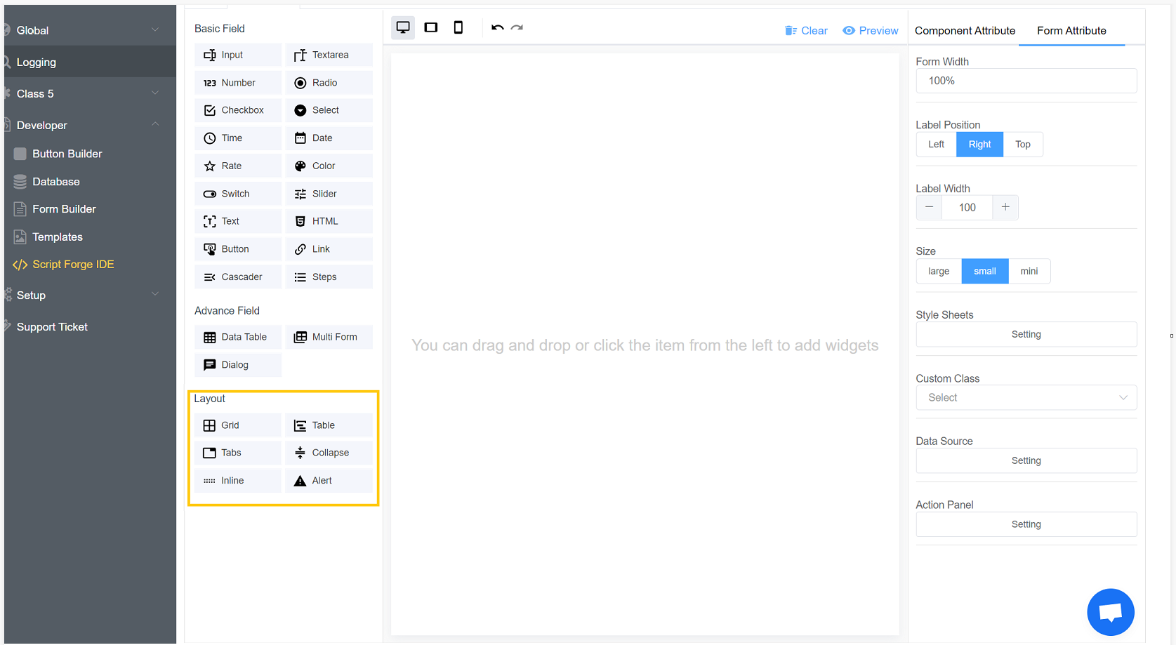

Figure 32: Layout Options

* 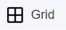: A grid is something that is in a pattern of straight lines that cross over each other, forming squares.

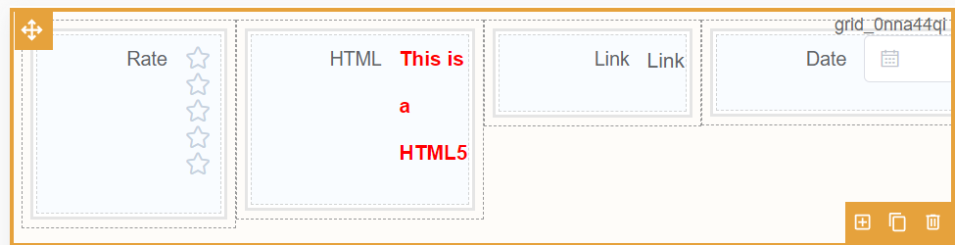

* : The table-layout property defines what algorithm the browser should use to lay out table rows, cells, and columns.

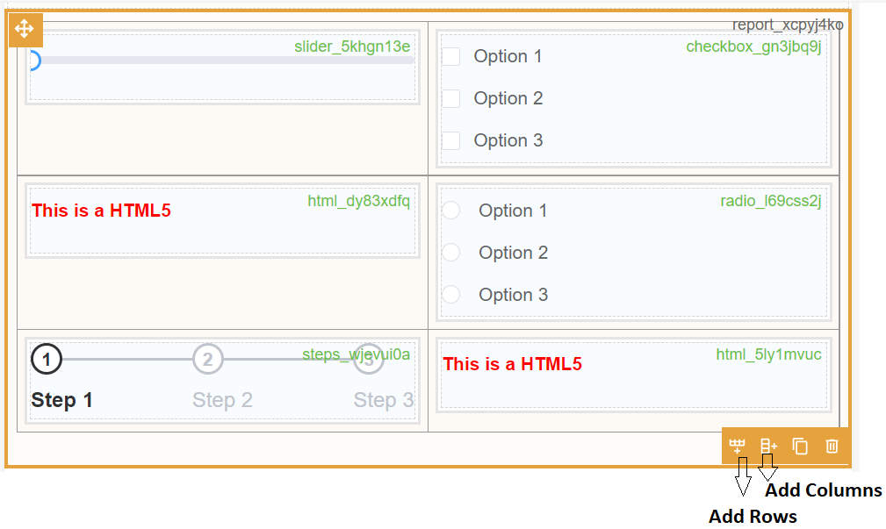

* 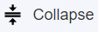: The collapse JavaScript plugin is used to show and hide content. Buttons or anchors are used as triggers that are mapped to specific elements you toggle.

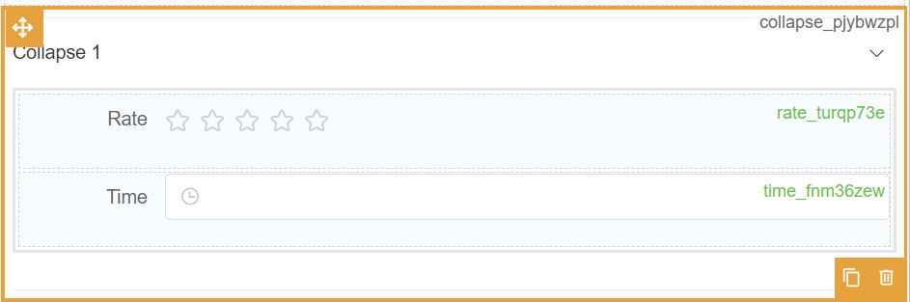

* 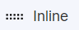: In inline layout, a mixed, recursive stream of text and inline-level boxes forming an inline formatting context within a block container are laid out by fragmenting them into a stack of line boxes and aligning the text and boxes to each other within each line box.

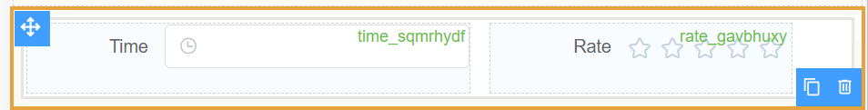

* 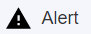: In notification UX, an alert occurs in response to an event and can potentially trigger a notification, which is the act of bringing something to the notice of the user and a way for an app to send a message that can be read without opening the app, e.g., an email alert.

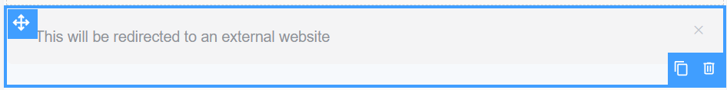

All the Basic and Advance Fields are discussed, for each component you can change the characteristics of each component. Let’s go through the characteristics of each component of Basic and Advance Fields.

**BASIC FIELDS**

1. Input

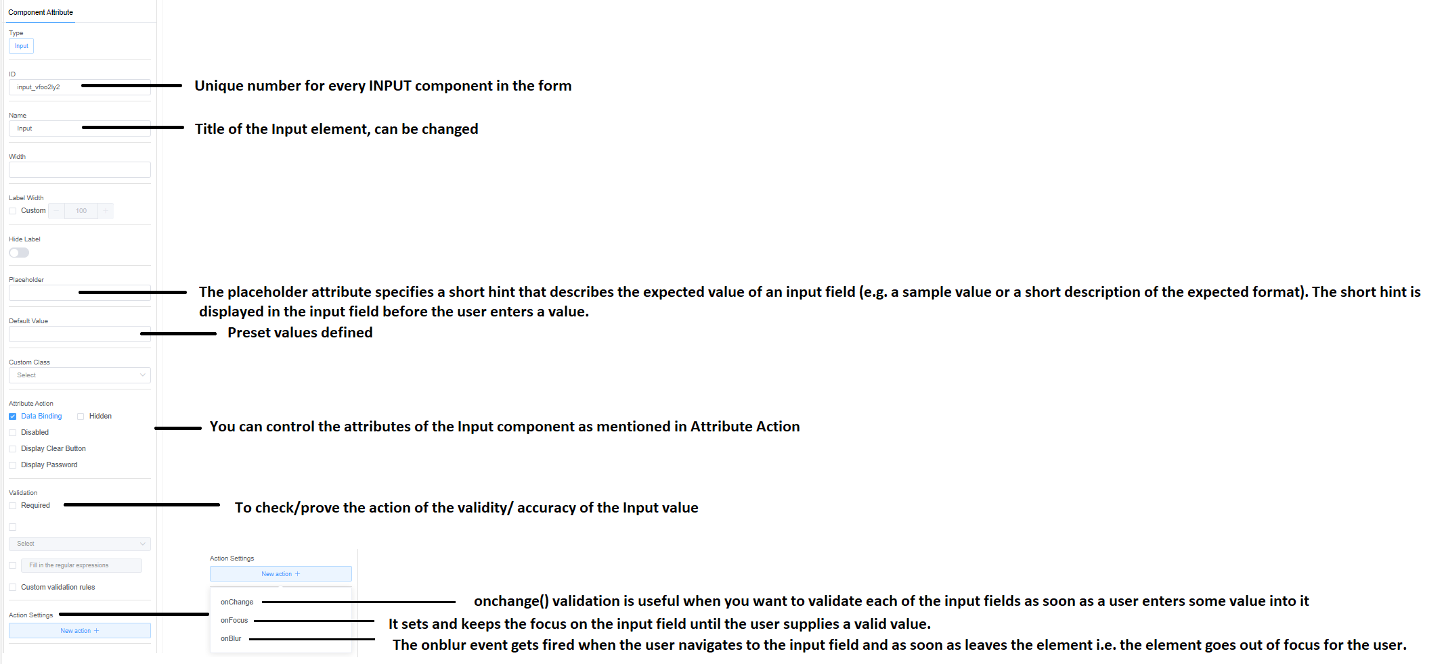

Figure 33: Component Attribute of Input Field

1. Textarea

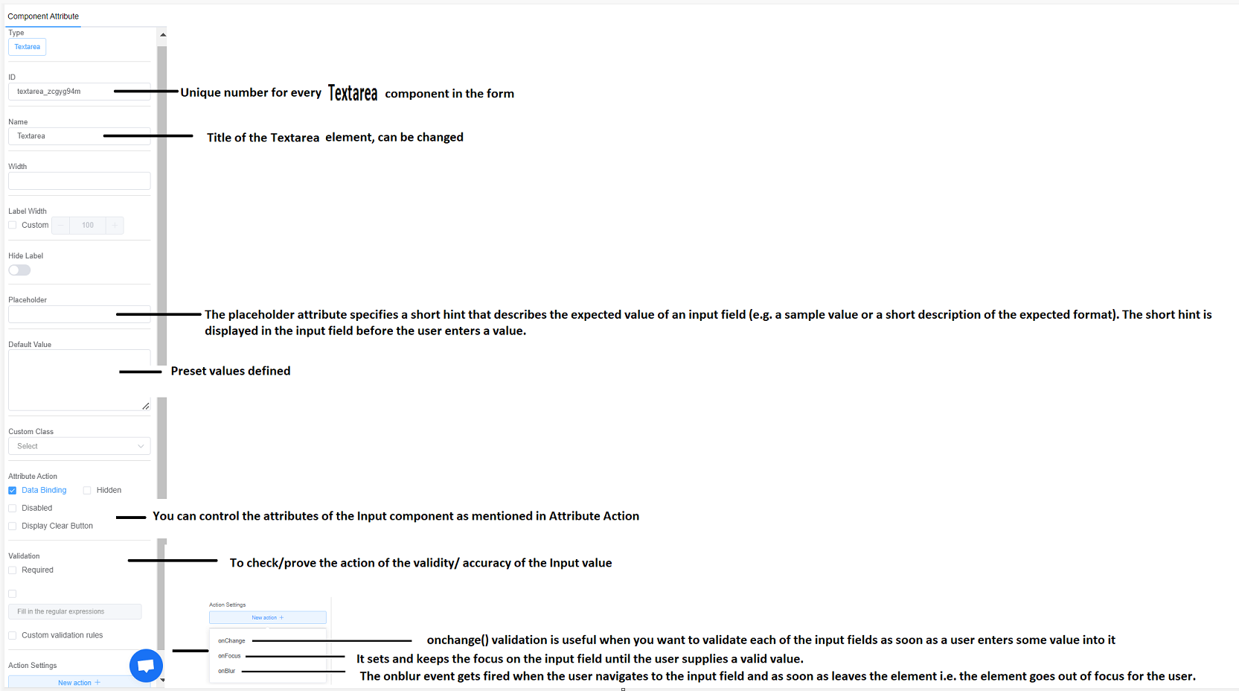

Figure 34: Component Attribute of Textarea

1. Number

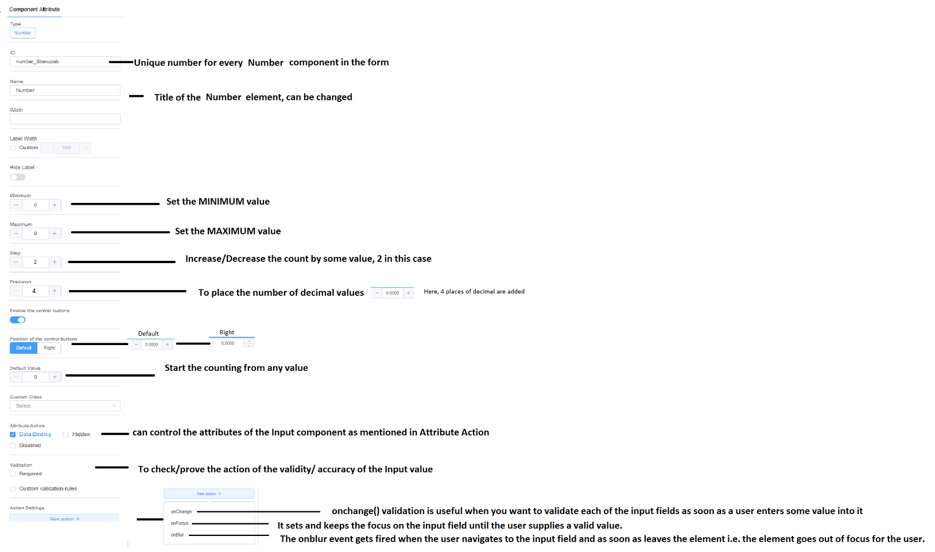

Figure 35: Component Attribute of Number

1. Radio

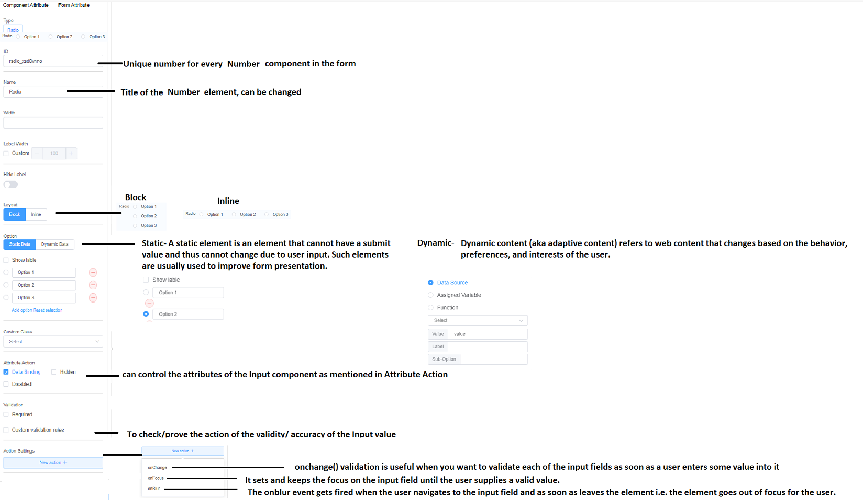

Figure 36: Component Attribute of Radio

1. Checkbox

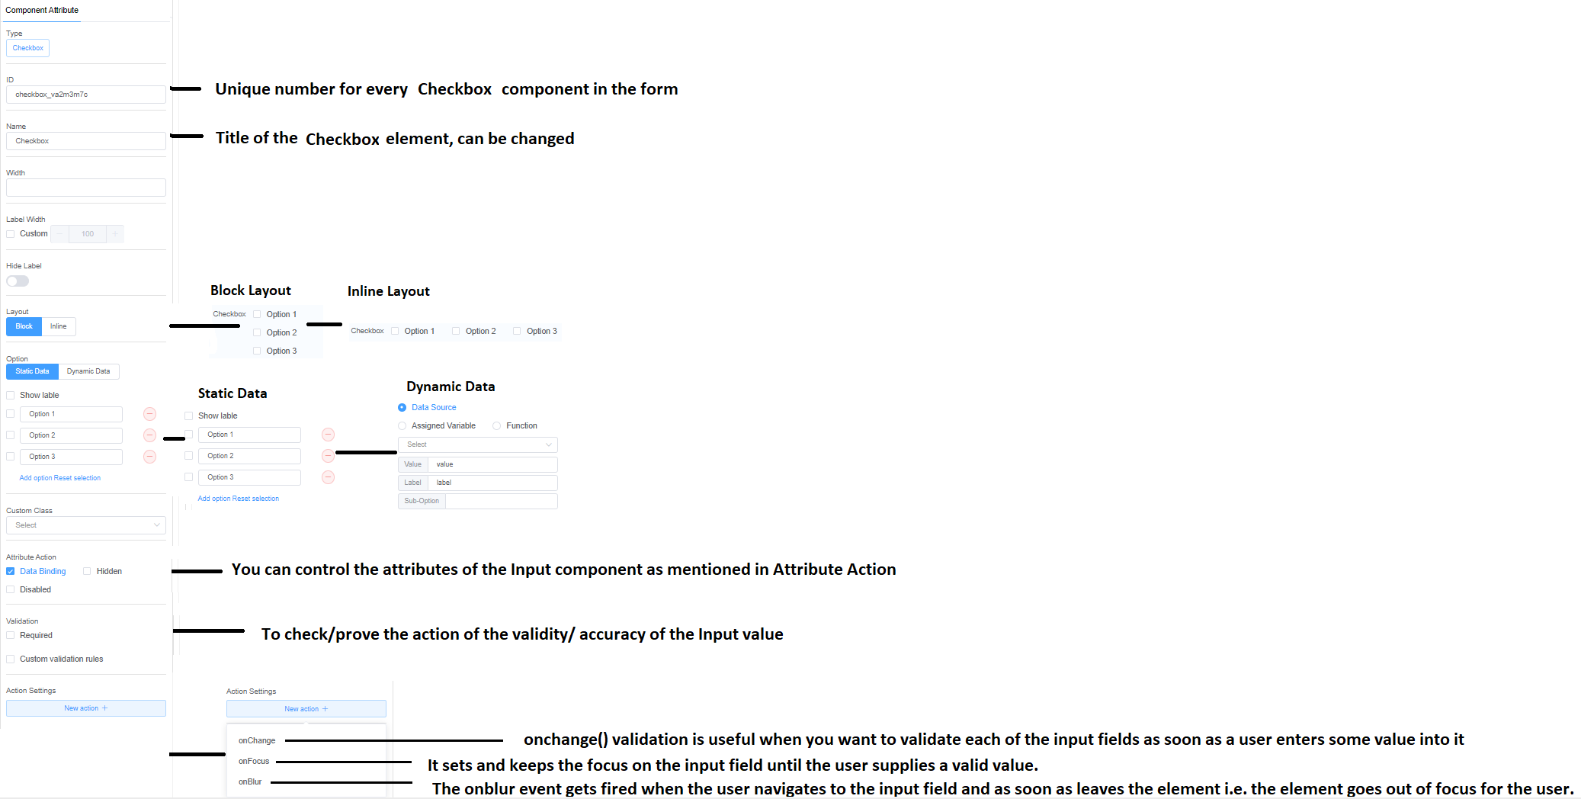

Figure 37: Component Attribute of Checkbox

1. Select

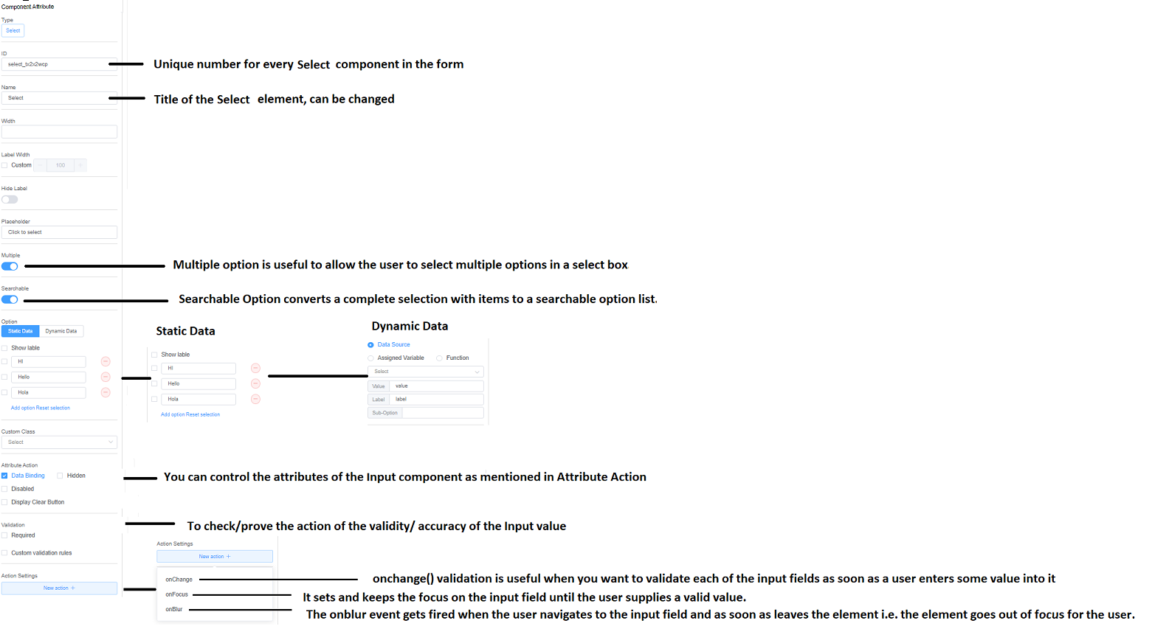

Figure 38: Component Attribute of Select

1. Time

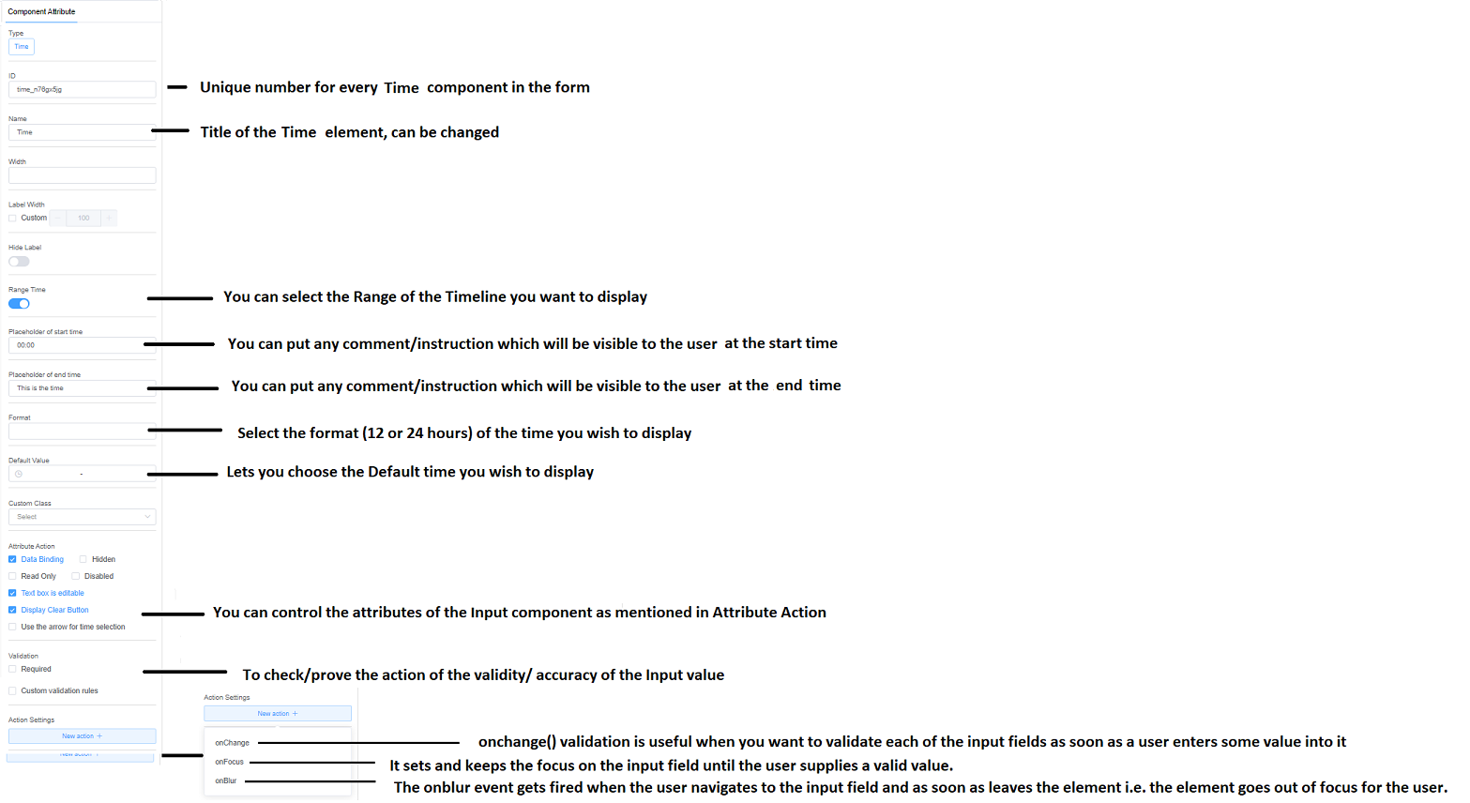

Figure 39: Component Attribute of Time

1. Date

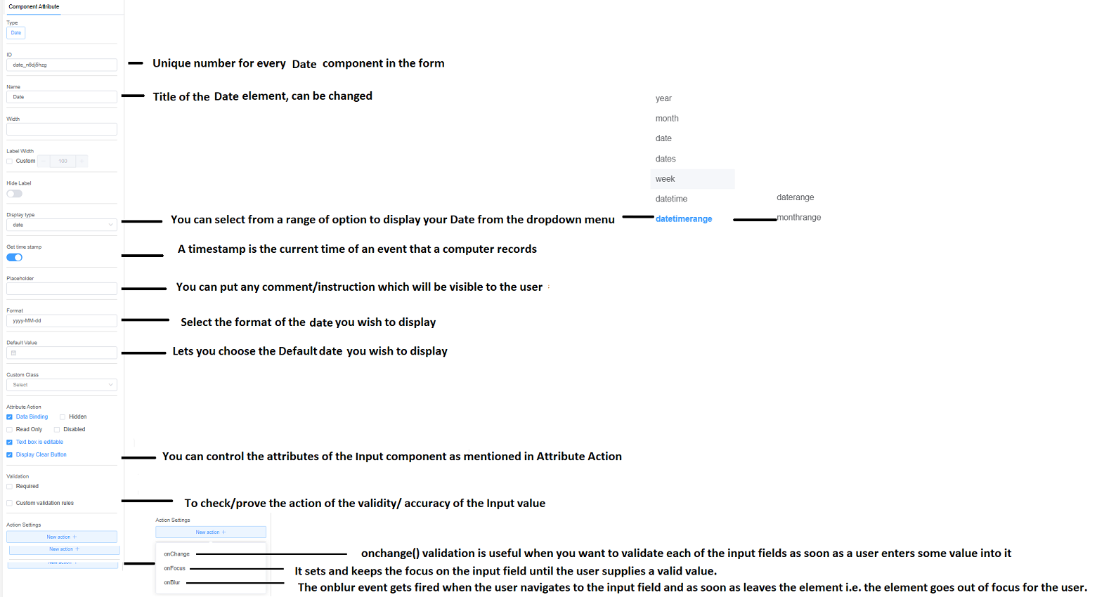

Figure 40: Component Attribute of Date

1. Rate

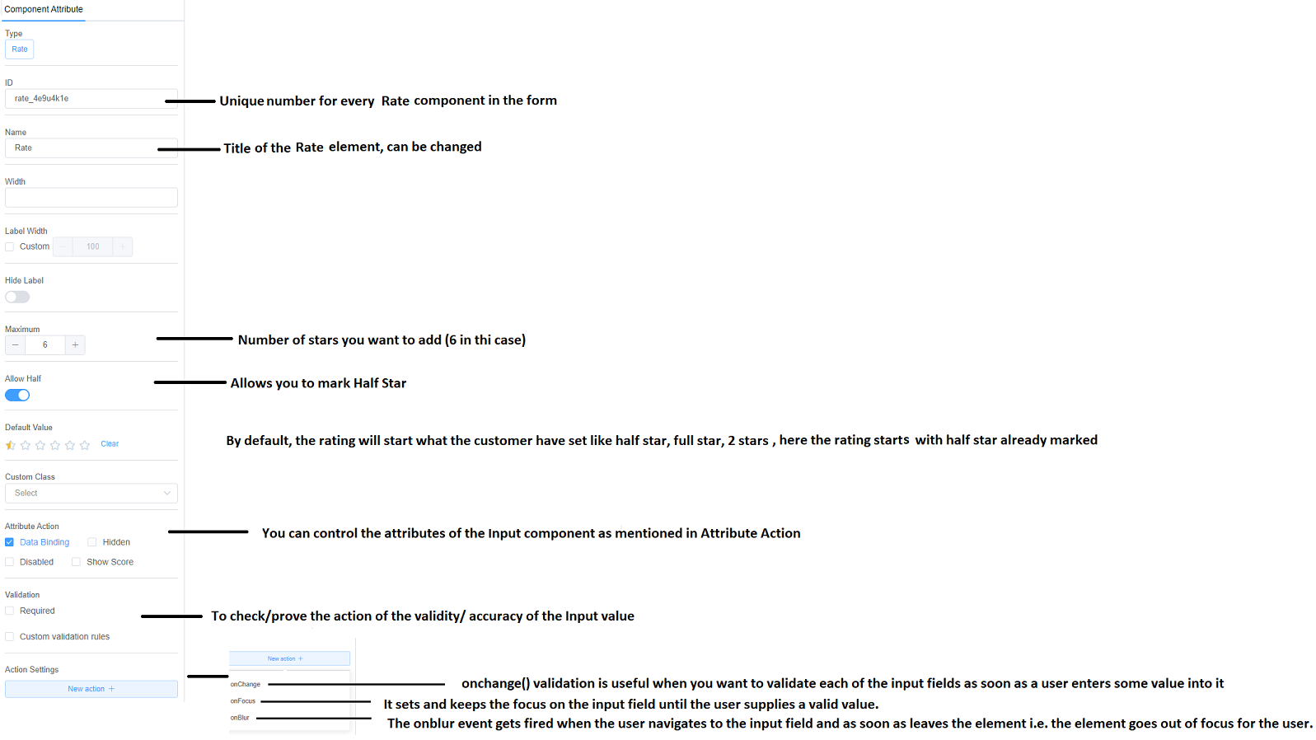

Figure 41: Component Attribute of Rate

1. Color

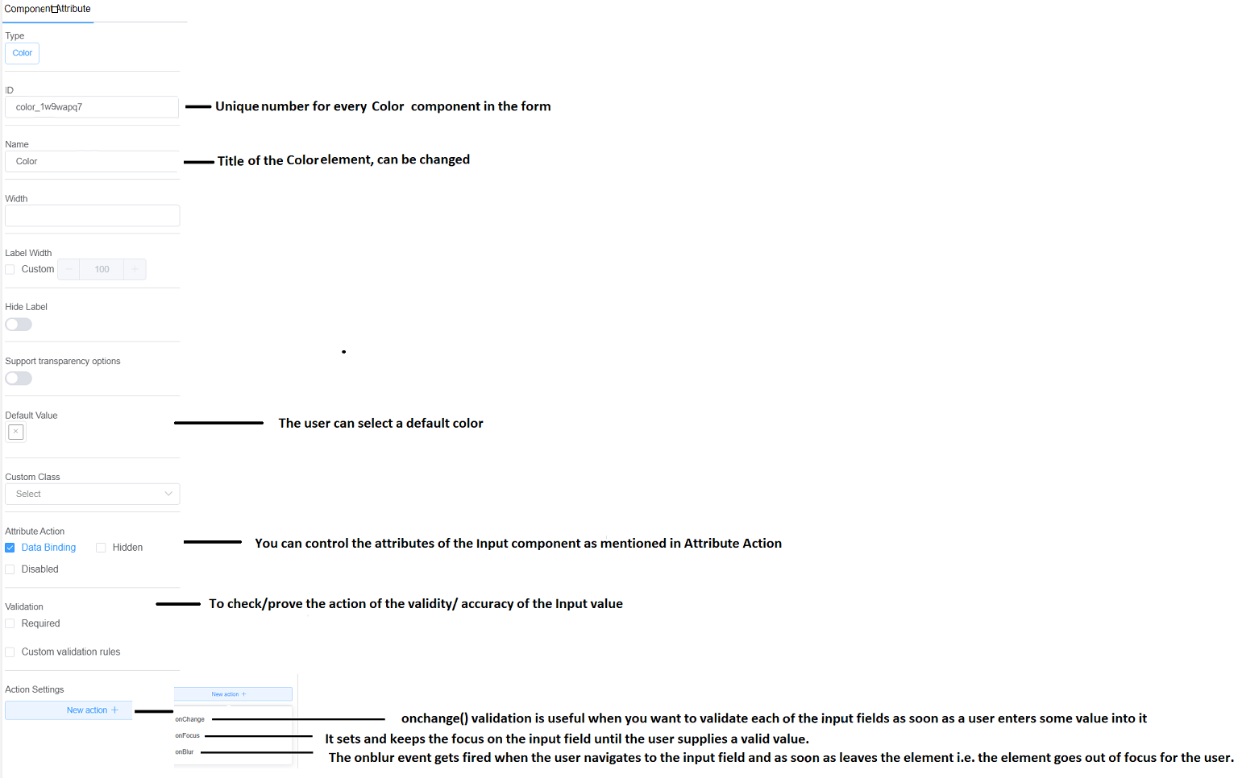

Figure 42: Component Attribute of Color

1. Switch

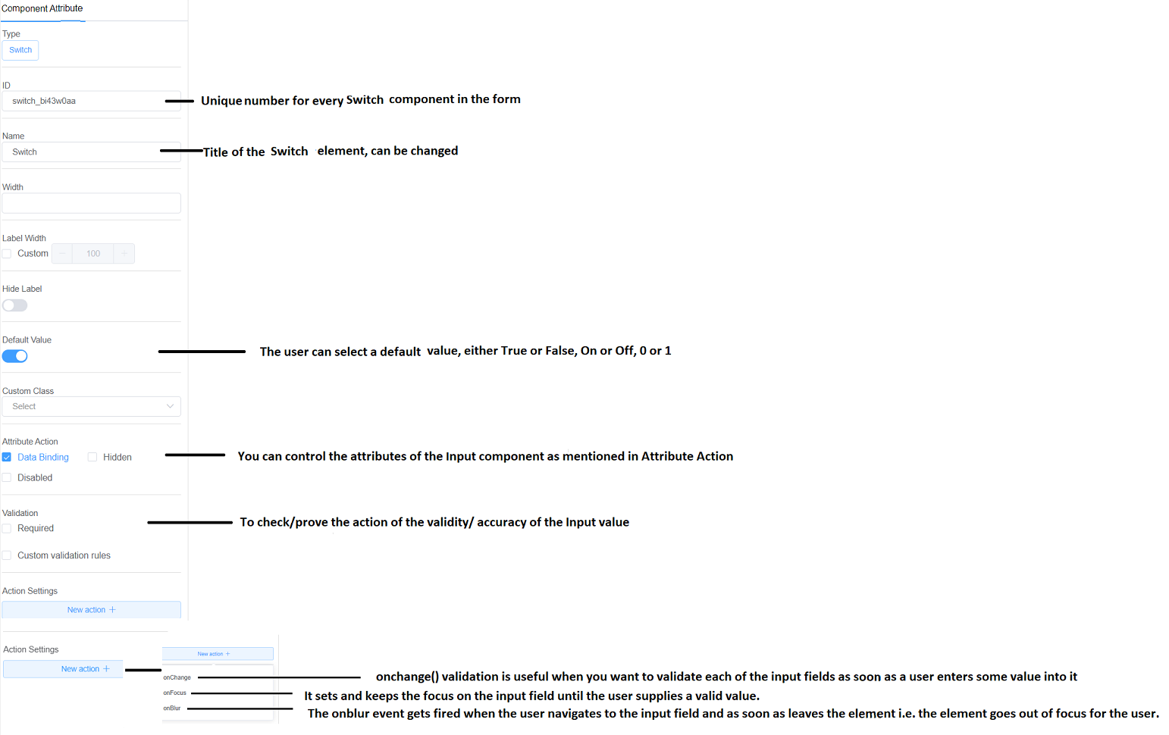

Figure 43: Component Attribute of Switch

1. Slider

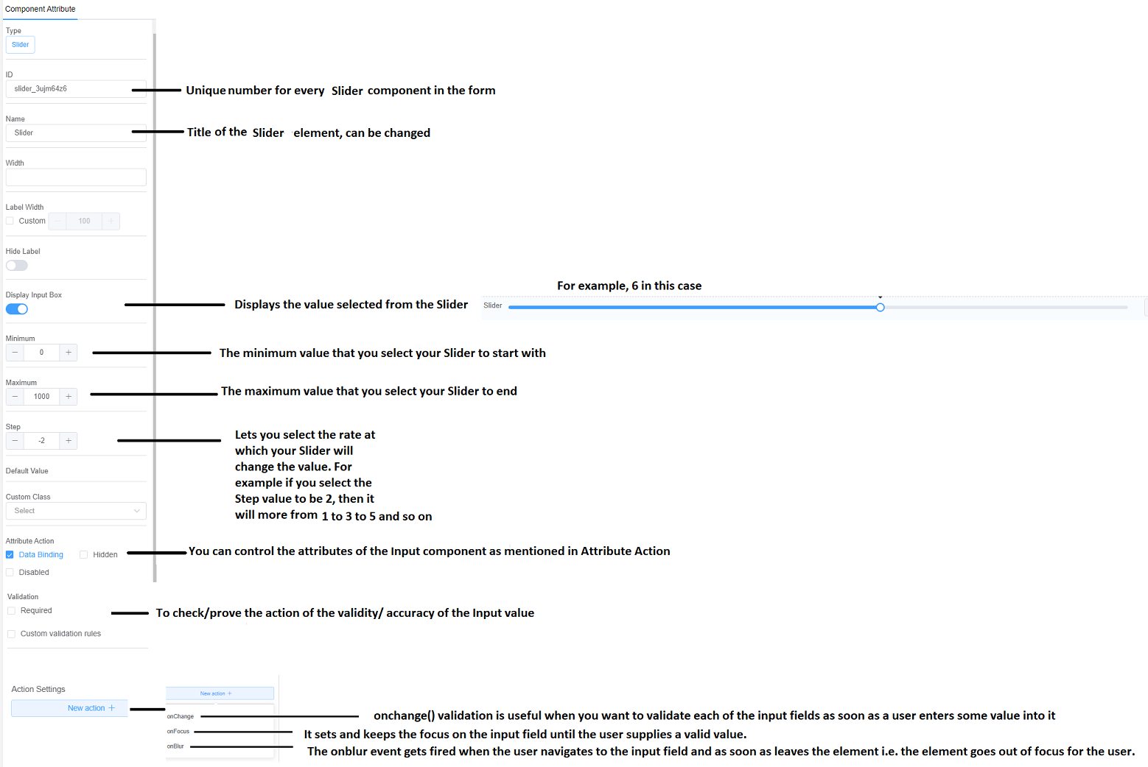

Figure 44: Component Attribute of Slider

1. Text

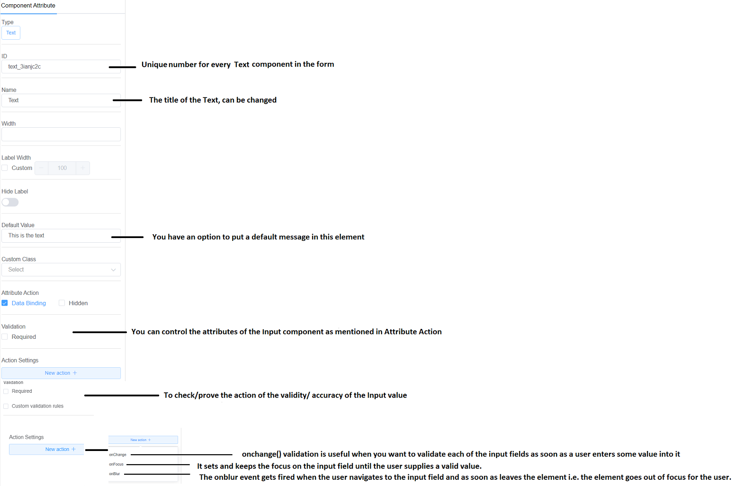

Figure 45: Component Attribute of Text

1. HTML

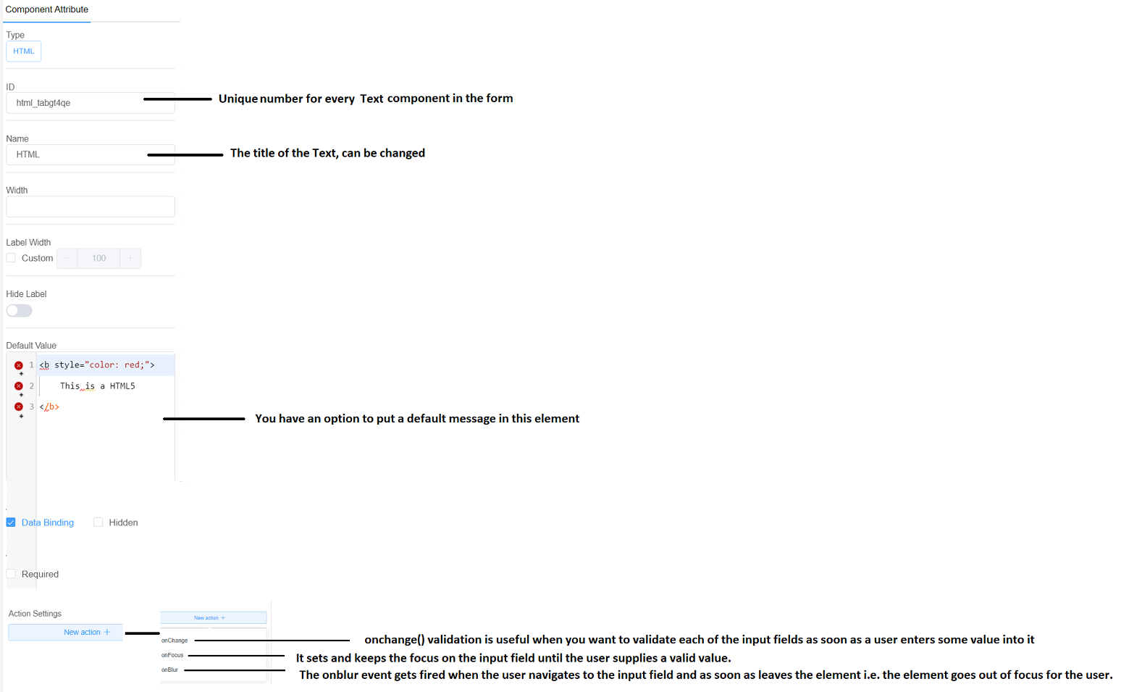

Figure 46: Component Attribute of HTML

1. Button

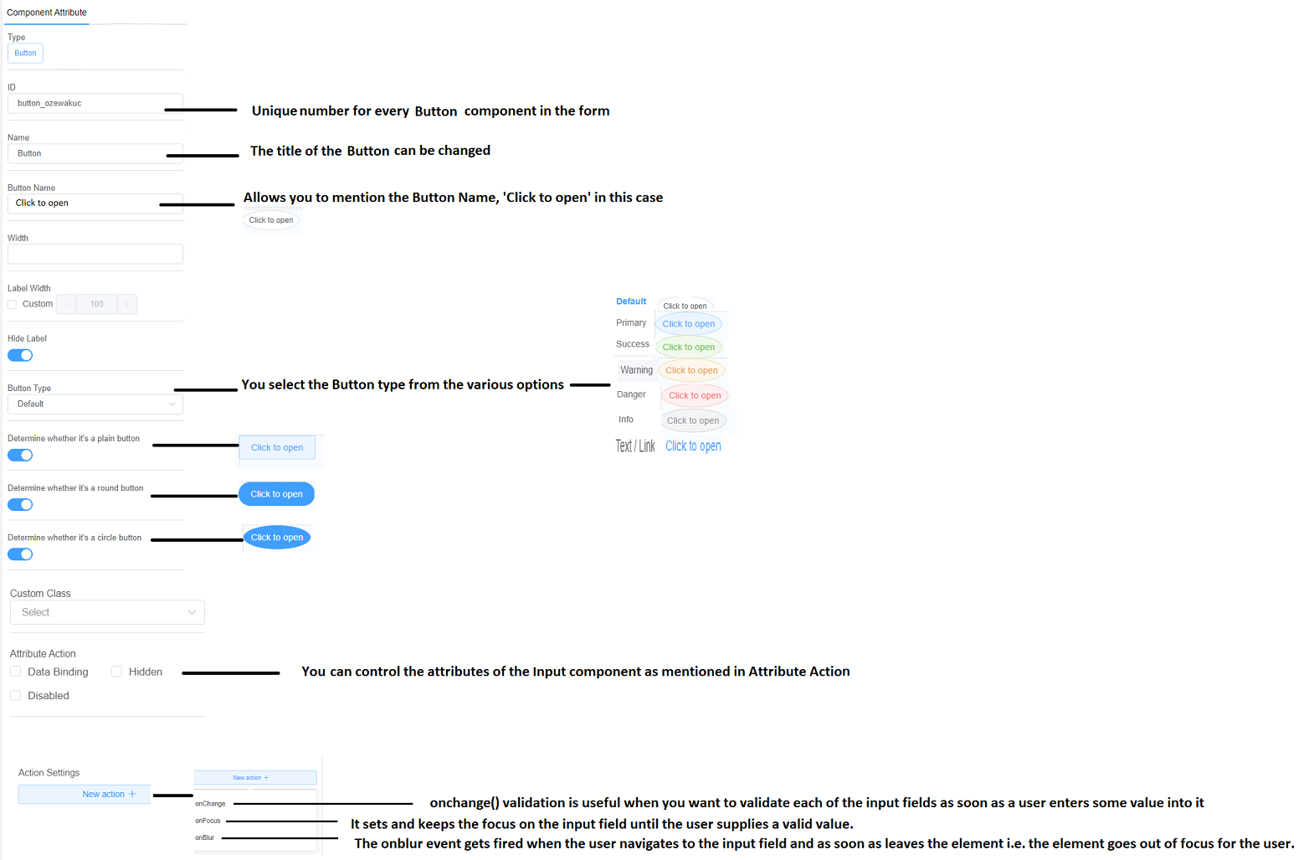

Figure 47: Component Attribute of Button

1. Link

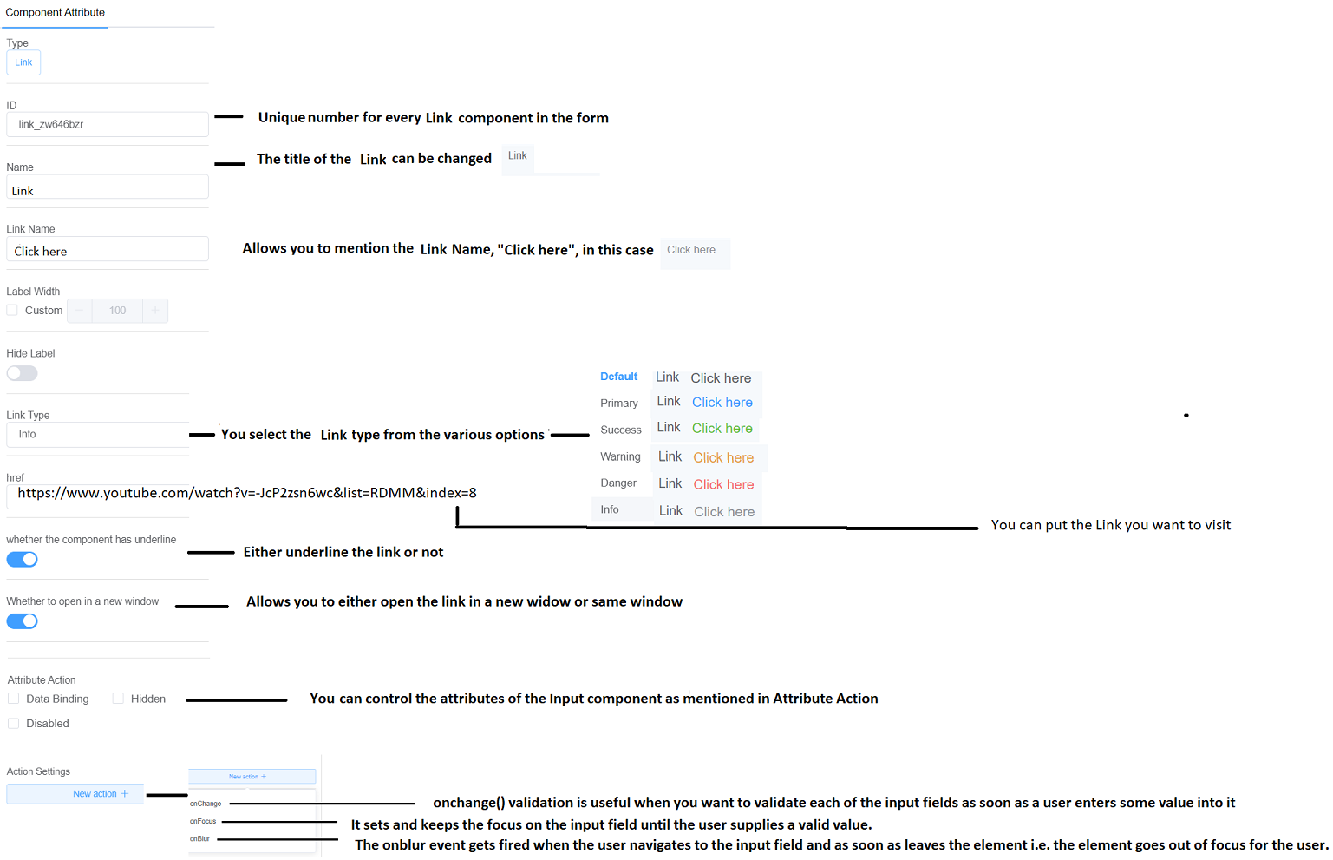

Figure 48: Component Attribute of Link

1. Cascader

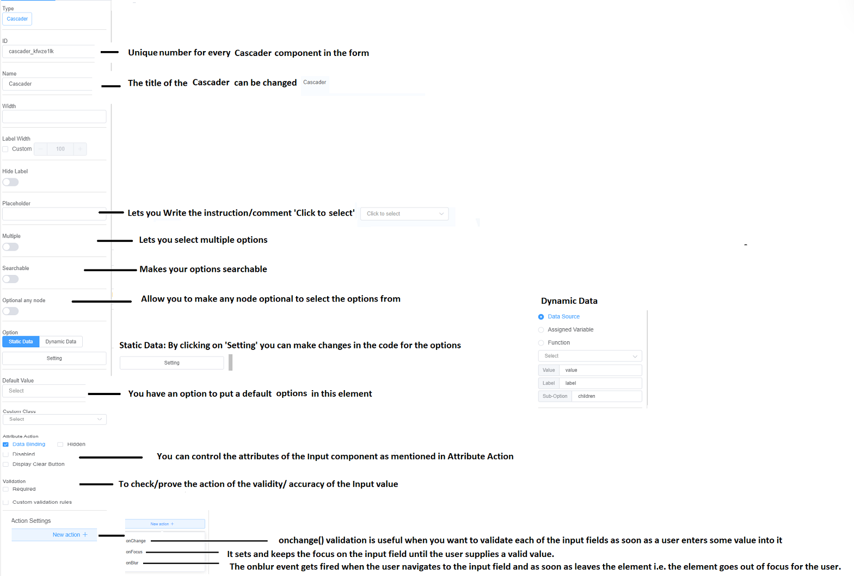

Figure 49: Component Attribute of Cascader

1. Steps

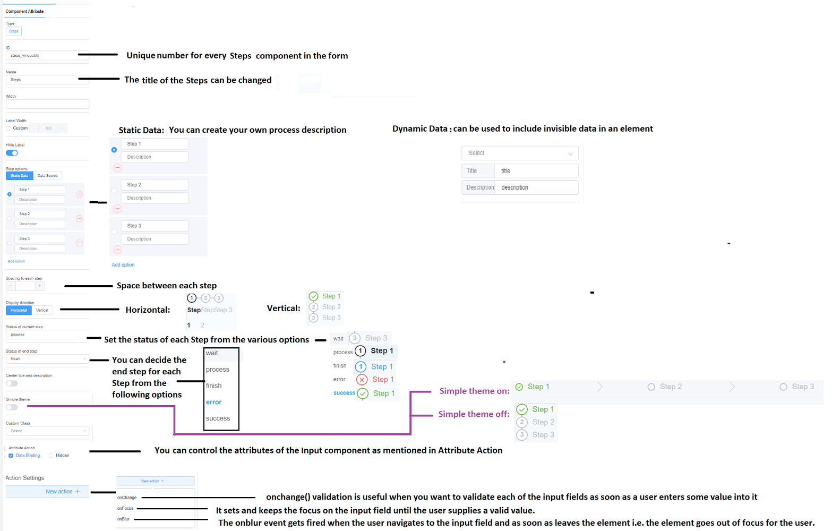

Figure 50: Component Attribute of Steps

**ADVANCE FIELDS**

1. Data Table

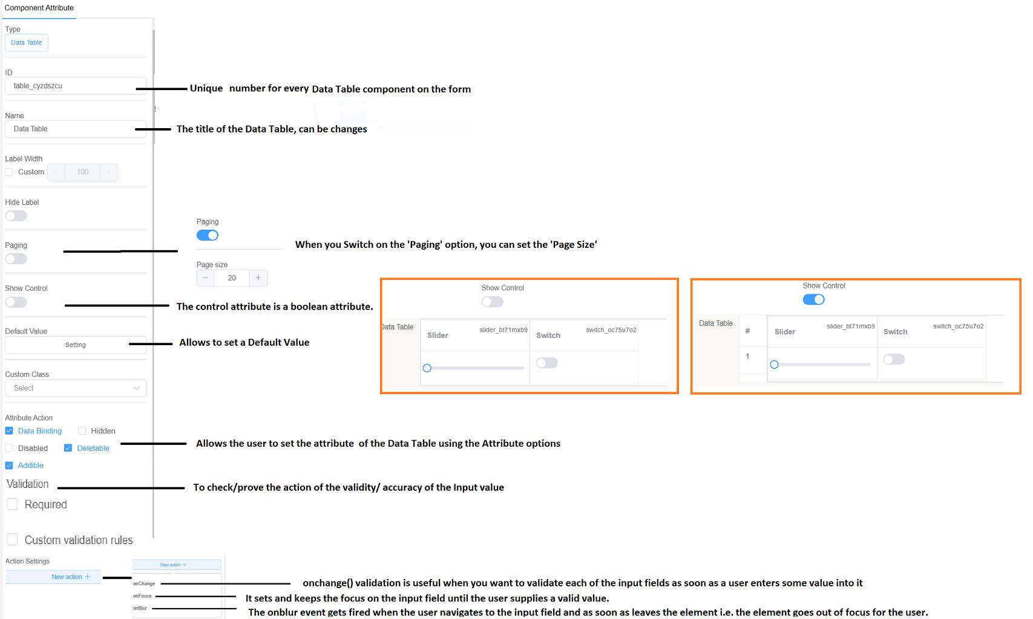

Figure 51: Component Attribute of Data Table

1. Multi Form: Multi Form has the same Component Attributes as that of the Data Table
2. Dialog box

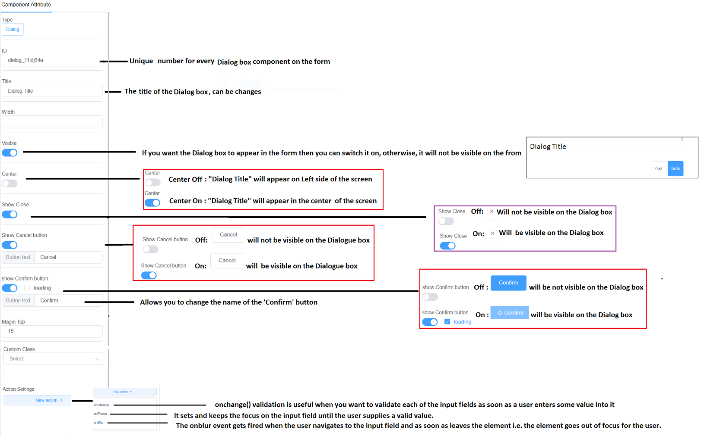

Figure 52: Component Attribute of the Dialog box

Let’s have a look at the Component Attributes of the **Layout**

1. Grid

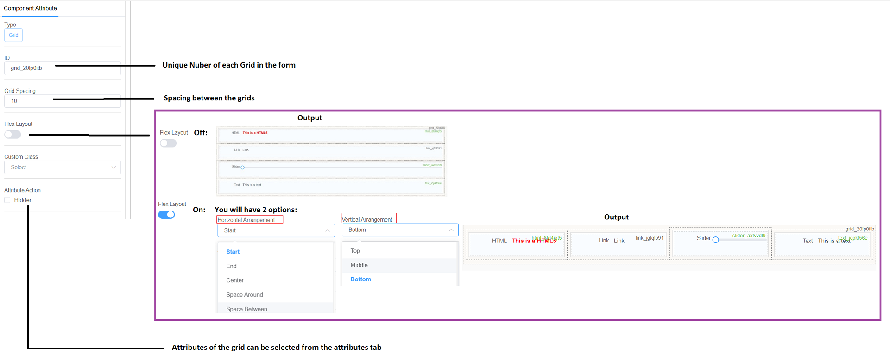

Figure 53: Component Attribute of Grid layout (whole gird)

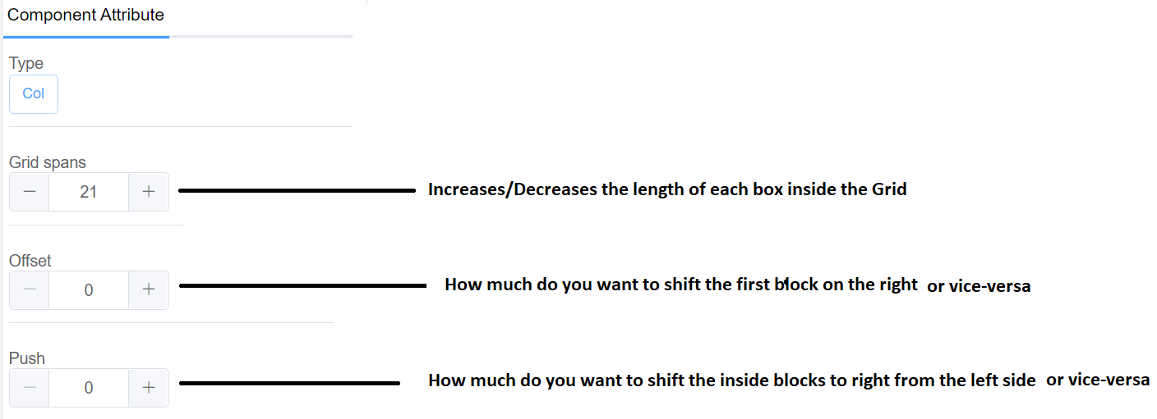 Figure 54: Component Attribute of Grid layout (for each block)

1. Table

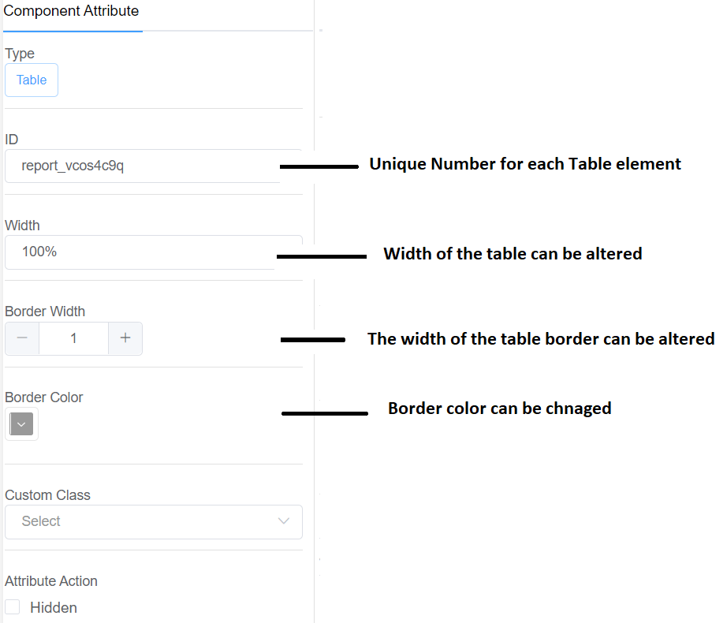

Figure 55: Component Attribute of the Table layout

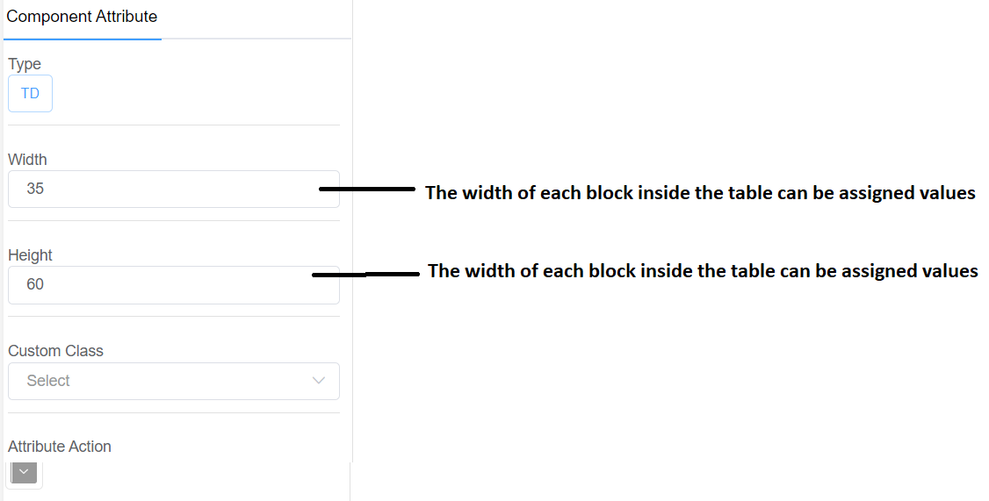

Figure 55: Component Attribute of Table layout (for each block)

1. Tab

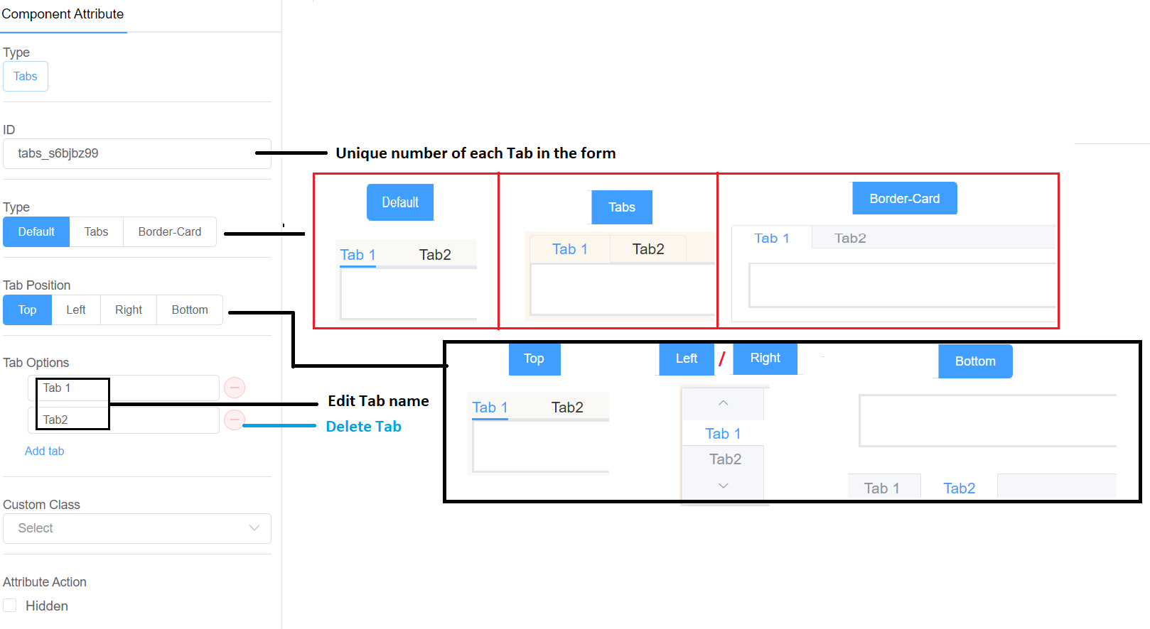

Figure 56: Component Attribute of Tab

1. Collapse

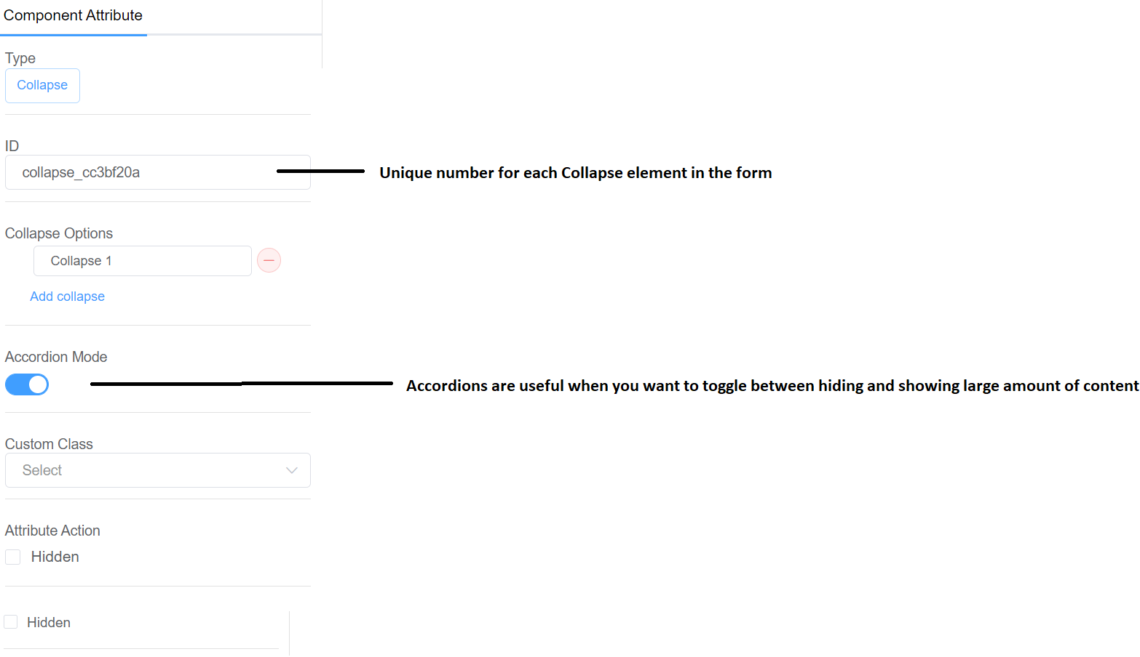

Figure 57: Component Attribute of Collapse

1. Alert

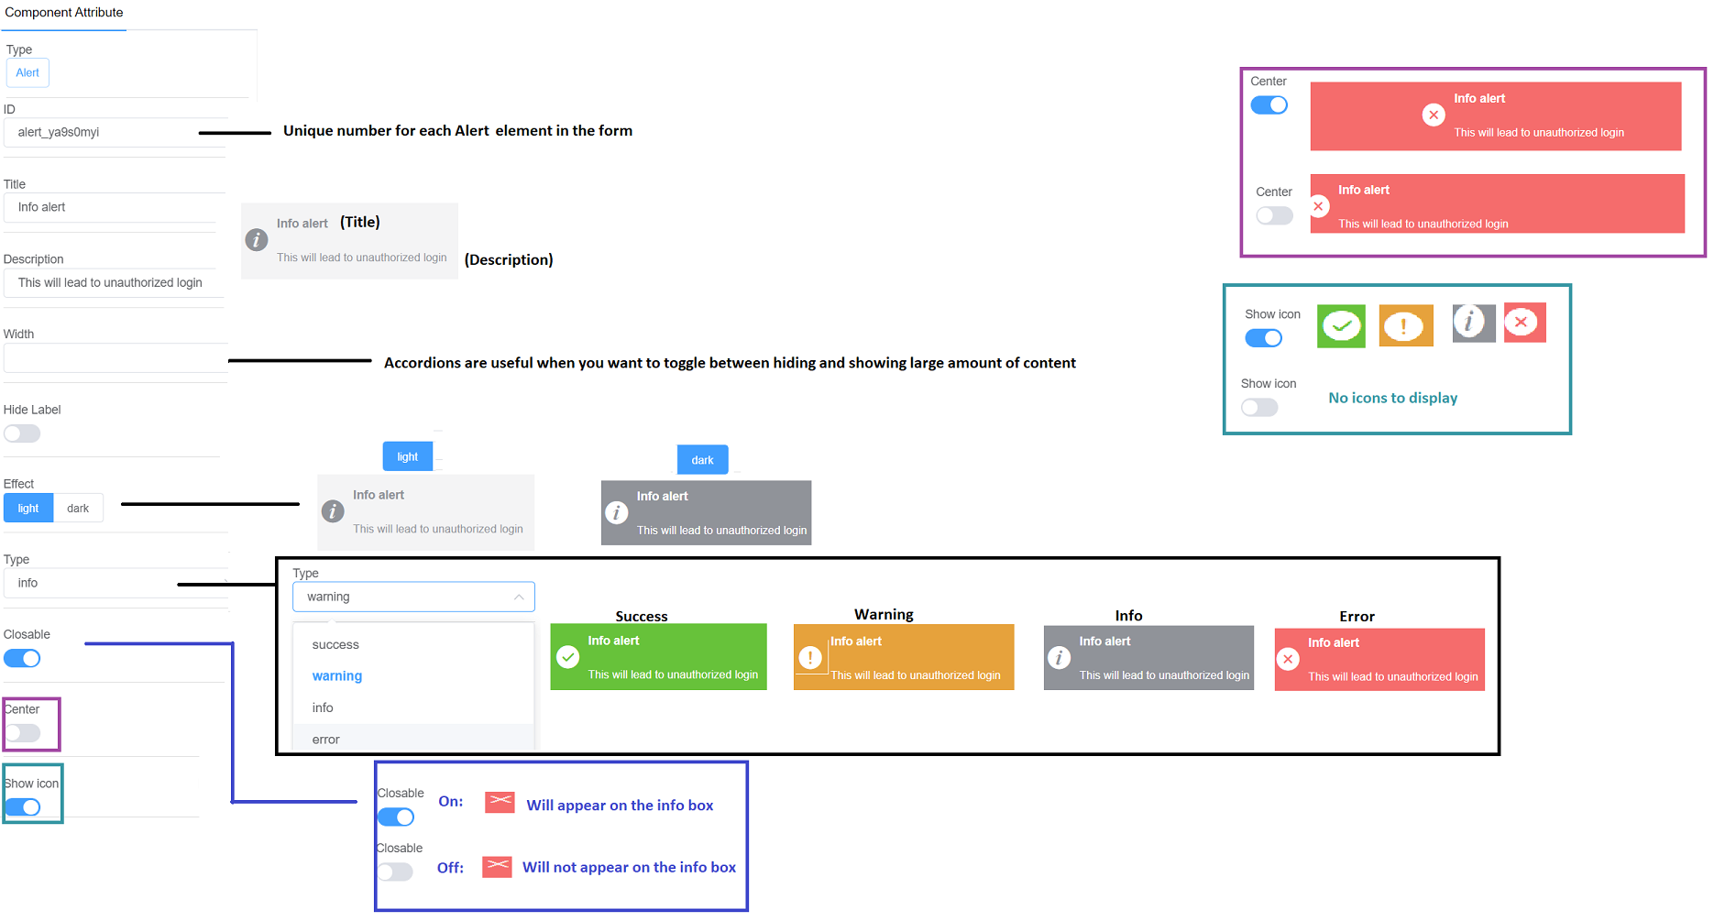

Figure 58: Component Attribute of Alert

We have discussed about the Component Attributes, now let’s discuss the **Form Attributes**

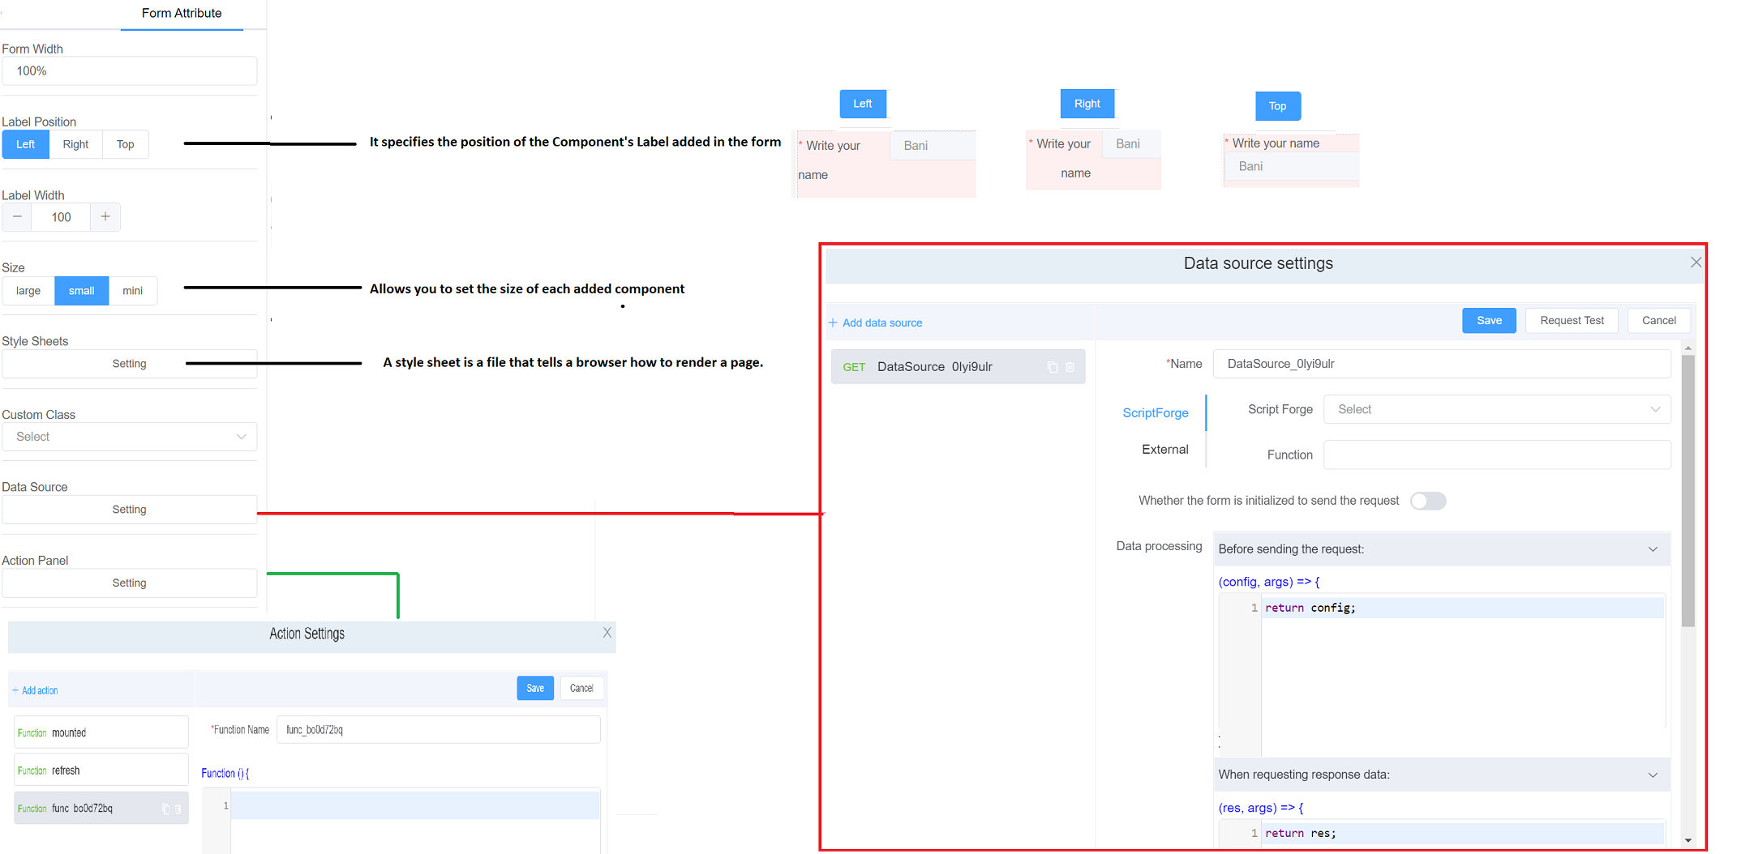

Figure 58: Form Attribute of Pages

Now that you have created your form, it’s time to preview it. Let’s discuss the preview styling and output screen.

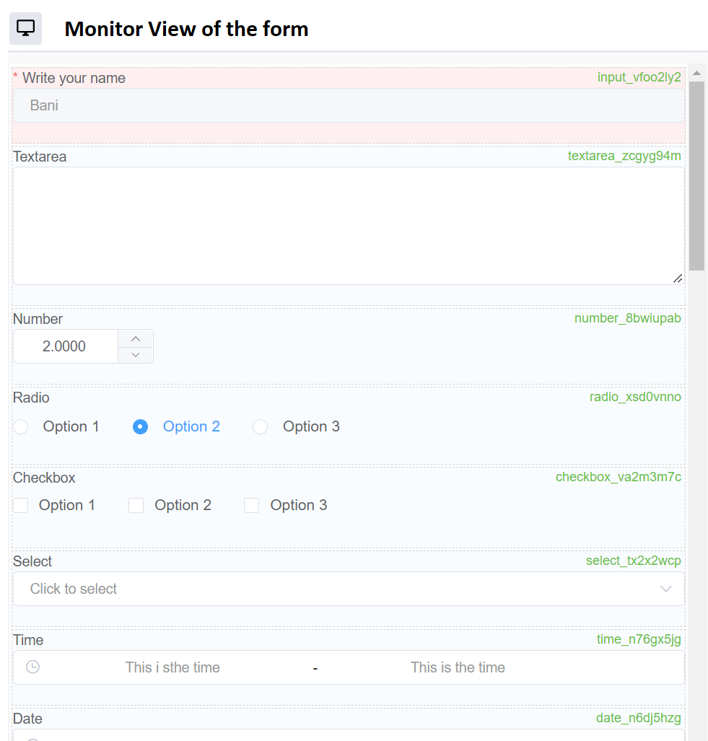

Figure 59: Monitor View of the Form

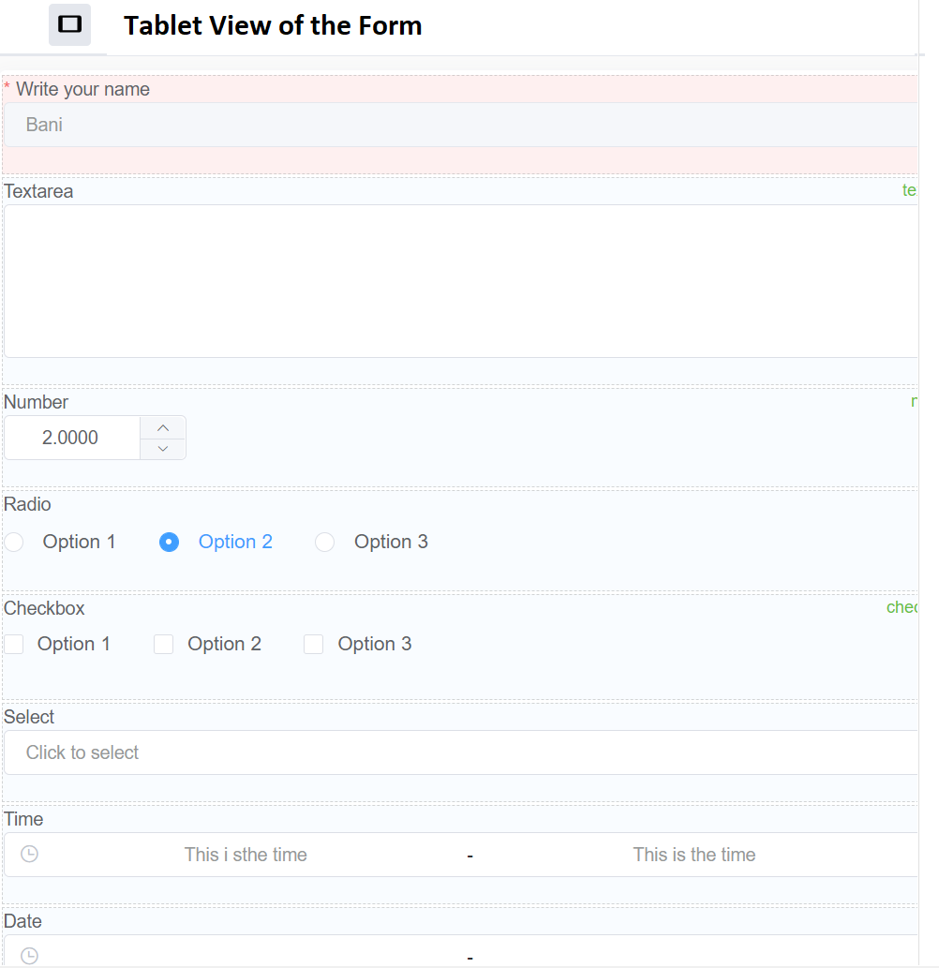

Figure 60: Tablet View of the Form

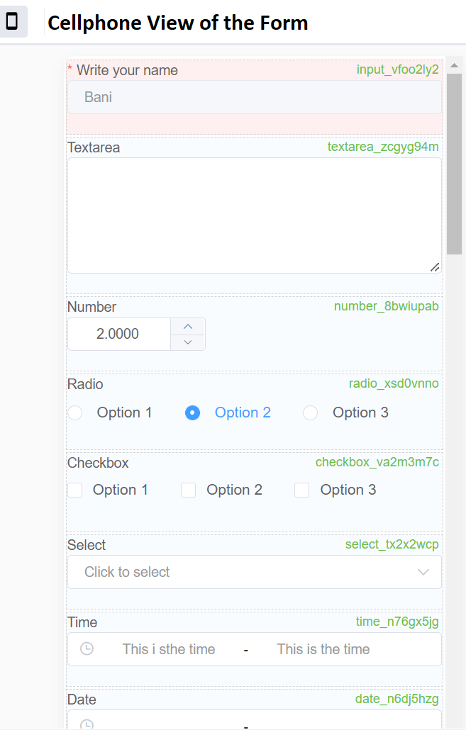

Figure 61: Cellphone View of the Form





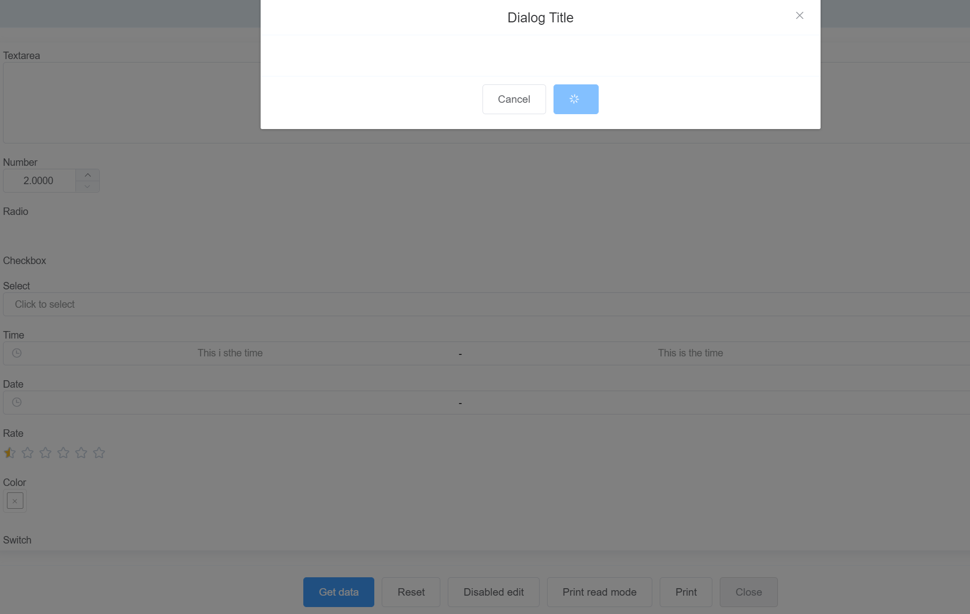

Figure 62: Form with Dialog Box

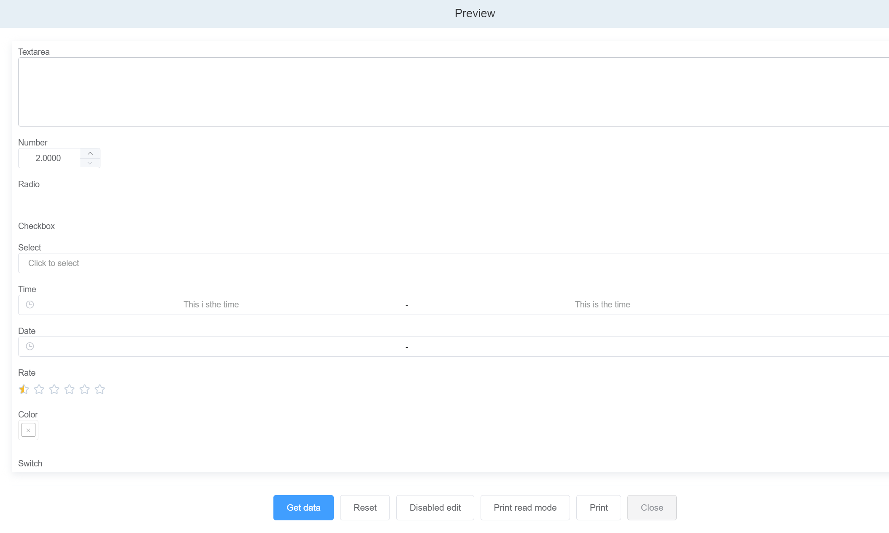 Figure 63: Form without Dialog Box

Click on **GET DATA** to generate

